**ADAMSON UNIVERSITY**

**College of Science**

**Information Technology &**

**Information Systems Department**

In partial fulfillment of the requirements in the course

IT225/IT225L Object Oriented Programming (Lec/Lab)

29052, 29051 / Mon 1030-1300, TTh 1100 - 1200

Submitted by:

|  |  |  |
| --- | --- | --- |
| **Group Name:** | | |
|  | **Name** | **Student Number** |
| **Leader:** | **Adrean Jan G. Quidor** | **202115198** |
| **Member 1:** | **Diomer L. Manaois** | **202115524** |
| **Member 2:** | **Job Kyla D. Noble** | **202113428** |
| **Member 3:** | **Gianne Lexter Baldonasa** | **202116586** |

Submitted to:

**MR. ARCHIE G. SANTIAGO**

Professor

05/22/2023

**TABLE OF CONTENTS**

1. Title of the System

GenBank Banking System.

1. Overview of the System

The GenBank Banking System is primarily focused on servicing the users of a banking company in their daily transactions via the desktop app using Java Swing. The GenBank Banking System has two main features: user account management and transaction processing system. The user account management deals with the user login, account registration, and account updates, including password resets. The transaction processing system involves checking balances, deposits, withdrawals, viewing, and searching for transactions.

1. Introduction

We proudly present the GenBank Banking System in response to the increasing demand for automated banking transactions driven by advancing technology. Our revolutionary desktop application empowers clients by delivering simple banking transactions at their fingertips in an instantaneous fashion. With our system, customers can conduct transactions with ease and convenience, eliminating the need to physically visit a bank branch. We have harnessed the power of technology to create a transformative banking experience that prioritizes efficiency, accessibility, and customer empowerment.

1. UML Class Diagram – explain/represent visually the classes and objects (properties and methods) used in your application.

1. Database and Table:
2. Screenshot of the Database and Table Design

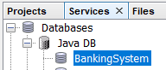 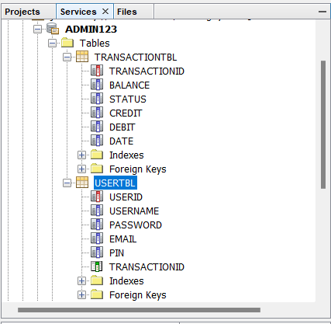

1. Table Records – show at least 10 sample records.

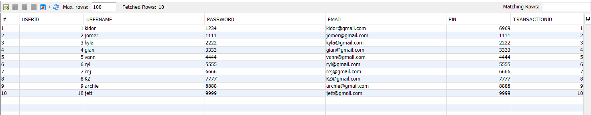

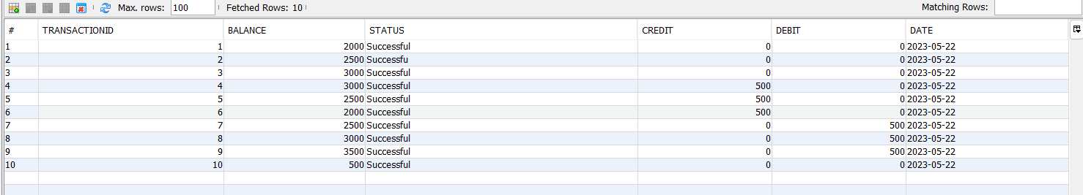

1. Screenshot of the Database driver and Database connection used.

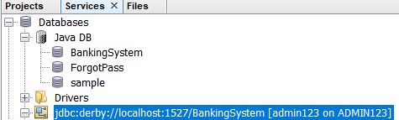

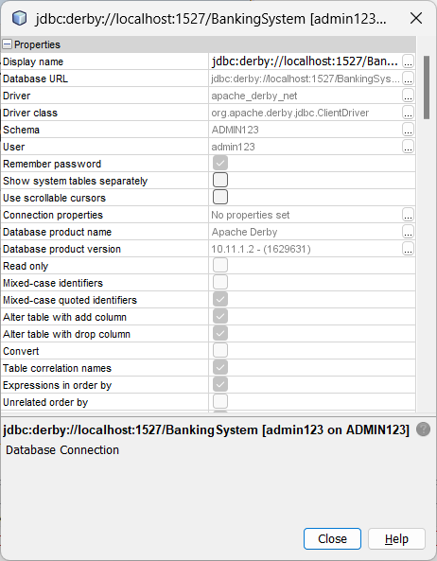

1. JFrame Forms **Design** (provide title/description of each form) and **Source Codes** used in each Form.

**userlogin.java**

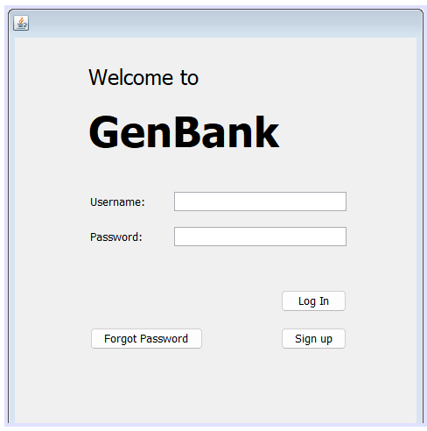

/*

* To change this license header, choose License Headers in Project Properties.

* To change this template file, choose Tools | Templates

* and open the template in the editor.

*/

package GenBank;

import java.sql.Connection;

import java.sql.DriverManager;

import java.sql.ResultSet;

import java.sql.Statement;

import java.util.HashSet;

import java.util.Set;

import javax.swing.JOptionPane;

/**

*

* @author ssuish

*/

public class UserLogin extends javax.swing.JFrame {

/**

* Creates new form UserAccountReset

*/

public UserLogin() {

initComponents();

}

/**

* This method is called from within the constructor to initialize the form.

* WARNING: Do NOT modify this code. The content of this method is always

* regenerated by the Form Editor.

*/

@SuppressWarnings("unchecked")

// <editor-fold defaultstate="collapsed" desc="Generated Code">

private void initComponents() {

jInternalFrame1 = new javax.swing.JInternalFrame();

jLabel2 = new javax.swing.JLabel();

jLabel3 = new javax.swing.JLabel();

btnLogin = new javax.swing.JButton();

username = new javax.swing.JTextField();

btnSignUp = new javax.swing.JButton();

btnForgotPassword = new javax.swing.JButton();

jLabel4 = new javax.swing.JLabel();

jLabel1 = new javax.swing.JLabel();

password = new javax.swing.JPasswordField();

setDefaultCloseOperation(javax.swing.WindowConstants.EXIT_ON_CLOSE);

jInternalFrame1.setVisible(true);

jLabel2.setText("Username:");

jLabel3.setText("Password:");

btnLogin.setText("Log In");

btnLogin.addActionListener(new java.awt.event.ActionListener() {

public void actionPerformed(java.awt.event.ActionEvent evt) {

btnLoginActionPerformed(evt);

}

});

username.addActionListener(new java.awt.event.ActionListener() {

public void actionPerformed(java.awt.event.ActionEvent evt) {

usernameActionPerformed(evt);

}

});

btnSignUp.setText("Sign up");

btnSignUp.addActionListener(new java.awt.event.ActionListener() {

public void actionPerformed(java.awt.event.ActionEvent evt) {

btnSignUpActionPerformed(evt);

}

});

btnForgotPassword.setText("Forgot Password");

btnForgotPassword.addActionListener(new java.awt.event.ActionListener() {

public void actionPerformed(java.awt.event.ActionEvent evt) {

btnForgotPasswordActionPerformed(evt);

}

});

jLabel4.setFont(new java.awt.Font("Tahoma", 1, 48)); // NOI18N

jLabel4.setText("GenBank ");

jLabel1.setFont(new java.awt.Font("Tahoma", 0, 24)); // NOI18N

jLabel1.setText("Welcome to");

password.setToolTipText("");

javax.swing.GroupLayout jInternalFrame1Layout = new javax.swing.GroupLayout(jInternalFrame1.getContentPane());

jInternalFrame1.getContentPane().setLayout(jInternalFrame1Layout);

jInternalFrame1Layout.setHorizontalGroup(

jInternalFrame1Layout.createParallelGroup(javax.swing.GroupLayout.Alignment.LEADING)

.addGroup(jInternalFrame1Layout.createSequentialGroup()

.addGap(84, 84, 84)

.addGroup(jInternalFrame1Layout.createParallelGroup(javax.swing.GroupLayout.Alignment.LEADING)

.addComponent(jLabel4)

.addComponent(jLabel1)

.addGroup(jInternalFrame1Layout.createSequentialGroup()

.addGap(2, 2, 2)

.addGroup(jInternalFrame1Layout.createParallelGroup(javax.swing.GroupLayout.Alignment.LEADING, false)

.addGroup(jInternalFrame1Layout.createSequentialGroup()

.addComponent(btnForgotPassword)

.addGap(89, 89, 89)

.addGroup(jInternalFrame1Layout.createParallelGroup(javax.swing.GroupLayout.Alignment.LEADING, false)

.addComponent(btnLogin, javax.swing.GroupLayout.DEFAULT_SIZE, javax.swing.GroupLayout.DEFAULT_SIZE, Short.MAX_VALUE)

.addComponent(btnSignUp, javax.swing.GroupLayout.DEFAULT_SIZE, javax.swing.GroupLayout.DEFAULT_SIZE, Short.MAX_VALUE)))

.addGroup(jInternalFrame1Layout.createSequentialGroup()

.addGroup(jInternalFrame1Layout.createParallelGroup(javax.swing.GroupLayout.Alignment.LEADING)

.addComponent(jLabel3)

.addComponent(jLabel2))

.addGap(33, 33, 33)

.addGroup(jInternalFrame1Layout.createParallelGroup(javax.swing.GroupLayout.Alignment.LEADING)

.addComponent(username)

.addComponent(password))))))

.addContainerGap(80, Short.MAX_VALUE))

);

jInternalFrame1Layout.setVerticalGroup(

jInternalFrame1Layout.createParallelGroup(javax.swing.GroupLayout.Alignment.LEADING)

.addGroup(jInternalFrame1Layout.createSequentialGroup()

.addGap(30, 30, 30)

.addComponent(jLabel1)

.addGap(18, 18, 18)

.addComponent(jLabel4)

.addGap(41, 41, 41)

.addGroup(jInternalFrame1Layout.createParallelGroup(javax.swing.GroupLayout.Alignment.BASELINE)

.addComponent(username, javax.swing.GroupLayout.PREFERRED_SIZE, javax.swing.GroupLayout.DEFAULT_SIZE, javax.swing.GroupLayout.PREFERRED_SIZE)

.addComponent(jLabel2))

.addGap(18, 18, 18)

.addGroup(jInternalFrame1Layout.createParallelGroup(javax.swing.GroupLayout.Alignment.BASELINE)

.addComponent(jLabel3)

.addComponent(password, javax.swing.GroupLayout.PREFERRED_SIZE, javax.swing.GroupLayout.DEFAULT_SIZE, javax.swing.GroupLayout.PREFERRED_SIZE))

.addGap(50, 50, 50)

.addComponent(btnLogin)

.addGap(18, 18, 18)

.addGroup(jInternalFrame1Layout.createParallelGroup(javax.swing.GroupLayout.Alignment.BASELINE)

.addComponent(btnSignUp)

.addComponent(btnForgotPassword))

.addContainerGap(77, Short.MAX_VALUE))

);

javax.swing.GroupLayout layout = new javax.swing.GroupLayout(getContentPane());

getContentPane().setLayout(layout);

layout.setHorizontalGroup(

layout.createParallelGroup(javax.swing.GroupLayout.Alignment.LEADING)

.addComponent(jInternalFrame1, javax.swing.GroupLayout.PREFERRED_SIZE, javax.swing.GroupLayout.DEFAULT_SIZE, javax.swing.GroupLayout.PREFERRED_SIZE)

);

layout.setVerticalGroup(

layout.createParallelGroup(javax.swing.GroupLayout.Alignment.LEADING)

.addComponent(jInternalFrame1, javax.swing.GroupLayout.PREFERRED_SIZE, javax.swing.GroupLayout.DEFAULT_SIZE, javax.swing.GroupLayout.PREFERRED_SIZE)

);

pack();

}// </editor-fold>

private void btnForgotPasswordActionPerformed(java.awt.event.ActionEvent evt) {

// TODO add your handling code here:

this.setVisible(false);

UserResetPassword reset = new UserResetPassword();

reset.setVisible(true);

}

private void btnSignUpActionPerformed(java.awt.event.ActionEvent evt) {

// TODO add your handling code here:

this.setVisible(false);

UserCreateAccount create = new UserCreateAccount();

create.setVisible(true);

}

private void usernameActionPerformed(java.awt.event.ActionEvent evt) {

// TODO add your handling code here:

}

private void btnLoginActionPerformed(java.awt.event.ActionEvent evt) {

// TODO add your handling code here:

String sql="Select * from USERTBL";

try {

Class.forName("org.apache.derby.jdbc.ClientDriver");

Connection con= (Connection) DriverManager.getConnection("jdbc:derby://localhost:1527/BankingSystem", "admin123", "12345678");

Statement stmt=con.createStatement();

ResultSet rs = stmt.executeQuery(sql);

String user=username.getText();

String pwd= new String (password.getPassword());

while(rs.next()) {

String uname = rs.getString("username");

//Username is the coloumn name in the database table

String password=rs.getString("password");

if ((user.equals(uname)) && (pwd.equals(password)))

this.setVisible(false);

new PromptLoginPIN().setVisible(true);

break;

}

}

catch (Exception e){

JOptionPane.showMessageDialog(this, e.getMessage());

}

}

/**

* @param args the command line arguments

*/

public static void main(String args[]) {

/* Set the Nimbus look and feel */

//<editor-fold defaultstate="collapsed" desc=" Look and feel setting code (optional) ">

/* If Nimbus (introduced in Java SE 6) is not available, stay with the default look and feel.

* For details see http://download.oracle.com/javase/tutorial/uiswing/lookandfeel/plaf.html

*/

try {

for (javax.swing.UIManager.LookAndFeelInfo info : javax.swing.UIManager.getInstalledLookAndFeels()) {

if ("Nimbus".equals(info.getName())) {

javax.swing.UIManager.setLookAndFeel(info.getClassName());

break;

}

}

} catch (ClassNotFoundException ex) {

java.util.logging.Logger.getLogger(UserLogin.class.getName()).log(java.util.logging.Level.SEVERE, null, ex);

} catch (InstantiationException ex) {

java.util.logging.Logger.getLogger(UserLogin.class.getName()).log(java.util.logging.Level.SEVERE, null, ex);

} catch (IllegalAccessException ex) {

java.util.logging.Logger.getLogger(UserLogin.class.getName()).log(java.util.logging.Level.SEVERE, null, ex);

} catch (javax.swing.UnsupportedLookAndFeelException ex) {

java.util.logging.Logger.getLogger(UserLogin.class.getName()).log(java.util.logging.Level.SEVERE, null, ex);

}

//</editor-fold>

//</editor-fold>

/* Create and display the form */

java.awt.EventQueue.invokeLater(new Runnable() {

public void run() {

new UserLogin().setVisible(true);

}

});

}

// Variables declaration - do not modify

private javax.swing.JButton btnForgotPassword;

private javax.swing.JButton btnLogin;

private javax.swing.JButton btnSignUp;

private javax.swing.JInternalFrame jInternalFrame1;

private javax.swing.JLabel jLabel1;

private javax.swing.JLabel jLabel2;

private javax.swing.JLabel jLabel3;

private javax.swing.JLabel jLabel4;

private javax.swing.JPasswordField password;

private javax.swing.JTextField username;

// End of variables declaration

}

**PromptLoginPIN.java**

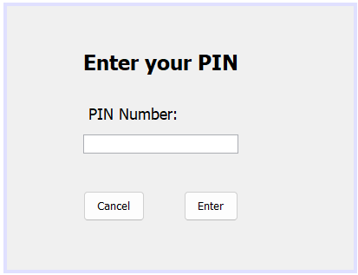

/*

* To change this license header, choose License Headers in Project Properties.

* To change this template file, choose Tools | Templates

* and open the template in the editor.

*/

package GenBank;

import java.sql.*;

import javax.swing.*;

/**

*

* @author ssuish

*/

public class PromptLoginPIN extends javax.swing.JFrame {

/**

* Creates new form PromptLoginPIN

*/

public PromptLoginPIN() {

initComponents();

}

/**

* This method is called from within the constructor to initialize the form.

* WARNING: Do NOT modify this code. The content of this method is always

* regenerated by the Form Editor.

*/

@SuppressWarnings("unchecked")

// <editor-fold defaultstate="collapsed" desc="Generated Code">

private void initComponents() {

jLabel1 = new javax.swing.JLabel();

jLabel2 = new javax.swing.JLabel();

jButton1 = new javax.swing.JButton();

jButton2 = new javax.swing.JButton();

password = new javax.swing.JPasswordField();

setDefaultCloseOperation(javax.swing.WindowConstants.EXIT_ON_CLOSE);

jLabel1.setFont(new java.awt.Font("Tahoma", 1, 24)); // NOI18N

jLabel1.setText("Enter your PIN");

jLabel2.setFont(new java.awt.Font("Tahoma", 0, 18)); // NOI18N

jLabel2.setText(" PIN Number:");

jButton1.setText("Enter");

jButton1.addActionListener(new java.awt.event.ActionListener() {

public void actionPerformed(java.awt.event.ActionEvent evt) {

jButton1ActionPerformed(evt);

}

});

jButton2.setText("Cancel");

jButton2.addActionListener(new java.awt.event.ActionListener() {

public void actionPerformed(java.awt.event.ActionEvent evt) {

jButton2ActionPerformed(evt);

}

});

javax.swing.GroupLayout layout = new javax.swing.GroupLayout(getContentPane());

getContentPane().setLayout(layout);

layout.setHorizontalGroup(

layout.createParallelGroup(javax.swing.GroupLayout.Alignment.LEADING)

.addGroup(layout.createSequentialGroup()

.addGap(88, 88, 88)

.addGroup(layout.createParallelGroup(javax.swing.GroupLayout.Alignment.LEADING, false)

.addComponent(jLabel1, javax.swing.GroupLayout.DEFAULT_SIZE, javax.swing.GroupLayout.DEFAULT_SIZE, Short.MAX_VALUE)

.addComponent(jLabel2)

.addGroup(layout.createSequentialGroup()

.addComponent(jButton2)

.addGap(45, 45, 45)

.addComponent(jButton1))

.addComponent(password))

.addContainerGap(133, Short.MAX_VALUE))

);

layout.setVerticalGroup(

layout.createParallelGroup(javax.swing.GroupLayout.Alignment.LEADING)

.addGroup(layout.createSequentialGroup()

.addGap(50, 50, 50)

.addComponent(jLabel1)

.addGap(34, 34, 34)

.addComponent(jLabel2)

.addPreferredGap(javax.swing.LayoutStyle.ComponentPlacement.UNRELATED)

.addComponent(password, javax.swing.GroupLayout.PREFERRED_SIZE, javax.swing.GroupLayout.DEFAULT_SIZE, javax.swing.GroupLayout.PREFERRED_SIZE)

.addPreferredGap(javax.swing.LayoutStyle.ComponentPlacement.RELATED, 43, Short.MAX_VALUE)

.addGroup(layout.createParallelGroup(javax.swing.GroupLayout.Alignment.BASELINE)

.addComponent(jButton1, javax.swing.GroupLayout.PREFERRED_SIZE, 35, javax.swing.GroupLayout.PREFERRED_SIZE)

.addComponent(jButton2, javax.swing.GroupLayout.PREFERRED_SIZE, 35, javax.swing.GroupLayout.PREFERRED_SIZE))

.addGap(56, 56, 56))

);

pack();

}// </editor-fold>

private void jButton2ActionPerformed(java.awt.event.ActionEvent evt) {

// TODO add your handling code here:

this.setVisible(false);

UserLogin usrlogin = new UserLogin();

usrlogin.setVisible(true);

}

private void jButton1ActionPerformed(java.awt.event.ActionEvent evt) {

// TODO add your handling code here:

String sql="Select * from USERTBL";

try {

Class.forName("org.apache.derby.jdbc.ClientDriver");

Connection con= (Connection) DriverManager.getConnection("jdbc:derby://localhost:1527/BankingSystem","admin123","12345678");

Statement stmt=con.createStatement();

ResultSet rs = stmt.executeQuery(sql);

String pwd= new String (password.getPassword());

while(rs.next()) {

String password=rs.getString("pin");

if (pwd.equals(password))

this.setVisible(false);

new MainPage().setVisible(true);

break;

}

}

catch (Exception e){

JOptionPane.showMessageDialog(this, e.getMessage());

}

}

/**

* @param args the command line arguments

*/

public static void main(String args[]) {

/* Set the Nimbus look and feel */

//<editor-fold defaultstate="collapsed" desc=" Look and feel setting code (optional) ">

/* If Nimbus (introduced in Java SE 6) is not available, stay with the default look and feel.

* For details see http://download.oracle.com/javase/tutorial/uiswing/lookandfeel/plaf.html

*/

try {

for (javax.swing.UIManager.LookAndFeelInfo info : javax.swing.UIManager.getInstalledLookAndFeels()) {

if ("Nimbus".equals(info.getName())) {

javax.swing.UIManager.setLookAndFeel(info.getClassName());

break;

}

}

} catch (ClassNotFoundException ex) {

java.util.logging.Logger.getLogger(PromptLoginPIN.class.getName()).log(java.util.logging.Level.SEVERE, null, ex);

} catch (InstantiationException ex) {

java.util.logging.Logger.getLogger(PromptLoginPIN.class.getName()).log(java.util.logging.Level.SEVERE, null, ex);

} catch (IllegalAccessException ex) {

java.util.logging.Logger.getLogger(PromptLoginPIN.class.getName()).log(java.util.logging.Level.SEVERE, null, ex);

} catch (javax.swing.UnsupportedLookAndFeelException ex) {

java.util.logging.Logger.getLogger(PromptLoginPIN.class.getName()).log(java.util.logging.Level.SEVERE, null, ex);

}

//</editor-fold>

/* Create and display the form */

java.awt.EventQueue.invokeLater(new Runnable() {

public void run() {

new PromptLoginPIN().setVisible(true);

}

});

}

// Variables declaration - do not modify

private javax.swing.JButton jButton1;

private javax.swing.JButton jButton2;

private javax.swing.JLabel jLabel1;

private javax.swing.JLabel jLabel2;

private javax.swing.JPasswordField password;

// End of variables declaration

}

**MainPage.java**

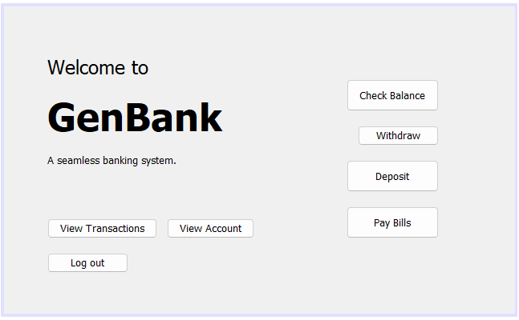

/*

* To change this license header, choose License Headers in Project Properties.

* To change this template file, choose Tools | Templates

* and open the template in the editor.

*/

package GenBank;

/**

*

* @author ssuish

*/

public class MainPage extends javax.swing.JFrame {

/**

* Creates new form MainPage

*/

public MainPage() {

initComponents();

}

/**

* This method is called from within the constructor to initialize the form.

* WARNING: Do NOT modify this code. The content of this method is always

* regenerated by the Form Editor.

*/

@SuppressWarnings("unchecked")

// <editor-fold defaultstate="collapsed" desc="Generated Code">

private void initComponents() {

jLabel5 = new javax.swing.JLabel();

jLabel1 = new javax.swing.JLabel();

jLabel2 = new javax.swing.JLabel();

jLabel4 = new javax.swing.JLabel();

btnCheckBalance = new javax.swing.JButton();

btnWithdraw = new javax.swing.JButton();

btnDeposit = new javax.swing.JButton();

btnPayBills = new javax.swing.JButton();

btnViewAccount = new javax.swing.JButton();

btnViewTransaction = new javax.swing.JButton();

btnLogOut = new javax.swing.JButton();

jLabel5.setText("jLabel5");

setDefaultCloseOperation(javax.swing.WindowConstants.EXIT_ON_CLOSE);

jLabel1.setFont(new java.awt.Font("Tahoma", 0, 24)); // NOI18N

jLabel1.setText("Welcome to");

jLabel2.setFont(new java.awt.Font("Tahoma", 1, 48)); // NOI18N

jLabel2.setText("GenBank ");

jLabel4.setText("A seamless banking system.");

btnCheckBalance.setText("Check Balance");

btnCheckBalance.addActionListener(new java.awt.event.ActionListener() {

public void actionPerformed(java.awt.event.ActionEvent evt) {

btnCheckBalanceActionPerformed(evt);

}

});

btnWithdraw.setText("Withdraw");

btnWithdraw.addActionListener(new java.awt.event.ActionListener() {

public void actionPerformed(java.awt.event.ActionEvent evt) {

btnWithdrawActionPerformed(evt);

}

});

btnDeposit.setText("Deposit");

btnDeposit.addActionListener(new java.awt.event.ActionListener() {

public void actionPerformed(java.awt.event.ActionEvent evt) {

btnDepositActionPerformed(evt);

}

});

btnPayBills.setText("Pay Bills");

btnPayBills.addActionListener(new java.awt.event.ActionListener() {

public void actionPerformed(java.awt.event.ActionEvent evt) {

btnPayBillsActionPerformed(evt);

}

});

btnViewAccount.setText("View Account");

btnViewAccount.addActionListener(new java.awt.event.ActionListener() {

public void actionPerformed(java.awt.event.ActionEvent evt) {

btnViewAccountActionPerformed(evt);

}

});

btnViewTransaction.setText("View Transactions");

btnViewTransaction.addActionListener(new java.awt.event.ActionListener() {

public void actionPerformed(java.awt.event.ActionEvent evt) {

btnViewTransactionActionPerformed(evt);

}

});

btnLogOut.setText("Log out");

btnLogOut.addActionListener(new java.awt.event.ActionListener() {

public void actionPerformed(java.awt.event.ActionEvent evt) {

btnLogOutActionPerformed(evt);

}

});

javax.swing.GroupLayout layout = new javax.swing.GroupLayout(getContentPane());

getContentPane().setLayout(layout);

layout.setHorizontalGroup(

layout.createParallelGroup(javax.swing.GroupLayout.Alignment.LEADING)

.addGroup(layout.createSequentialGroup()

.addGap(54, 54, 54)

.addGroup(layout.createParallelGroup(javax.swing.GroupLayout.Alignment.LEADING)

.addGroup(layout.createSequentialGroup()

.addComponent(btnLogOut, javax.swing.GroupLayout.PREFERRED_SIZE, 101, javax.swing.GroupLayout.PREFERRED_SIZE)

.addContainerGap(javax.swing.GroupLayout.DEFAULT_SIZE, Short.MAX_VALUE))

.addGroup(layout.createSequentialGroup()

.addGroup(layout.createParallelGroup(javax.swing.GroupLayout.Alignment.LEADING)

.addComponent(jLabel2)

.addComponent(jLabel1)

.addComponent(jLabel4)

.addGroup(layout.createSequentialGroup()

.addComponent(btnViewTransaction)

.addPreferredGap(javax.swing.LayoutStyle.ComponentPlacement.UNRELATED)

.addComponent(btnViewAccount)))

.addPreferredGap(javax.swing.LayoutStyle.ComponentPlacement.RELATED, 115, Short.MAX_VALUE)

.addGroup(layout.createParallelGroup(javax.swing.GroupLayout.Alignment.LEADING)

.addGroup(javax.swing.GroupLayout.Alignment.TRAILING, layout.createParallelGroup(javax.swing.GroupLayout.Alignment.LEADING, false)

.addComponent(btnPayBills, javax.swing.GroupLayout.DEFAULT_SIZE, javax.swing.GroupLayout.DEFAULT_SIZE, Short.MAX_VALUE)

.addComponent(btnCheckBalance, javax.swing.GroupLayout.DEFAULT_SIZE, javax.swing.GroupLayout.DEFAULT_SIZE, Short.MAX_VALUE)

.addComponent(btnDeposit, javax.swing.GroupLayout.DEFAULT_SIZE, javax.swing.GroupLayout.DEFAULT_SIZE, Short.MAX_VALUE))

.addComponent(btnWithdraw, javax.swing.GroupLayout.Alignment.TRAILING, javax.swing.GroupLayout.PREFERRED_SIZE, 101, javax.swing.GroupLayout.PREFERRED_SIZE))

.addGap(95, 95, 95))))

);

layout.setVerticalGroup(

layout.createParallelGroup(javax.swing.GroupLayout.Alignment.LEADING)

.addGroup(javax.swing.GroupLayout.Alignment.TRAILING, layout.createSequentialGroup()

.addGroup(layout.createParallelGroup(javax.swing.GroupLayout.Alignment.TRAILING)

.addGroup(layout.createSequentialGroup()

.addGap(91, 91, 91)

.addComponent(btnCheckBalance, javax.swing.GroupLayout.PREFERRED_SIZE, 40, javax.swing.GroupLayout.PREFERRED_SIZE)

.addGap(18, 18, 18)

.addComponent(btnWithdraw, javax.swing.GroupLayout.DEFAULT_SIZE, javax.swing.GroupLayout.DEFAULT_SIZE, Short.MAX_VALUE)

.addGap(18, 18, 18)

.addComponent(btnDeposit, javax.swing.GroupLayout.PREFERRED_SIZE, 40, javax.swing.GroupLayout.PREFERRED_SIZE))

.addGroup(layout.createSequentialGroup()

.addGap(61, 61, 61)

.addComponent(jLabel1)

.addGap(18, 18, 18)

.addComponent(jLabel2)

.addGap(18, 18, 18)

.addComponent(jLabel4)

.addGap(0, 0, Short.MAX_VALUE)))

.addGap(18, 18, 18)

.addGroup(layout.createParallelGroup(javax.swing.GroupLayout.Alignment.TRAILING)

.addComponent(btnPayBills, javax.swing.GroupLayout.PREFERRED_SIZE, 40, javax.swing.GroupLayout.PREFERRED_SIZE)

.addGroup(layout.createParallelGroup(javax.swing.GroupLayout.Alignment.BASELINE)

.addComponent(btnViewTransaction)

.addComponent(btnViewAccount)))

.addGap(18, 18, 18)

.addComponent(btnLogOut)

.addGap(51, 51, 51))

);

pack();

}// </editor-fold>

private void btnCheckBalanceActionPerformed(java.awt.event.ActionEvent evt) {

// TODO add your handling code here:

this.setVisible(false);

CheckBalance chkbal = new CheckBalance();

chkbal.setVisible(true);

}

private void btnWithdrawActionPerformed(java.awt.event.ActionEvent evt) {

// TODO add your handling code here:

this.setVisible(false);

Withdraw wth = new Withdraw();

wth.setVisible(true);

}

private void btnDepositActionPerformed(java.awt.event.ActionEvent evt) {

// TODO add your handling code here:

this.setVisible(false);

Deposit dps = new Deposit();

dps.setVisible(true);

}

private void btnPayBillsActionPerformed(java.awt.event.ActionEvent evt) {

// TODO add your handling code here:

this.setVisible(false);

PayBills paybill = new PayBills();

paybill.setVisible(true);

}

private void btnViewAccountActionPerformed(java.awt.event.ActionEvent evt) {

// TODO add your handling code here:

this.setVisible(false);

ViewAccount vwacc = new ViewAccount();

vwacc.setVisible(true);

}

private void btnViewTransactionActionPerformed(java.awt.event.ActionEvent evt) {

// TODO add your handling code here:

this.setVisible(false);

ViewTransaction vwtc = new ViewTransaction();

vwtc.setVisible(true);

}

private void btnLogOutActionPerformed(java.awt.event.ActionEvent evt) {

// TODO add your handling code here:

this.setVisible(false);

UserLogin usrlogin = new UserLogin();

usrlogin.setVisible(true);

}

/**

* @param args the command line arguments

*/

public static void main(String args[]) {

/* Set the Nimbus look and feel */

//<editor-fold defaultstate="collapsed" desc=" Look and feel setting code (optional) ">

/* If Nimbus (introduced in Java SE 6) is not available, stay with the default look and feel.

* For details see http://download.oracle.com/javase/tutorial/uiswing/lookandfeel/plaf.html

*/

try {

for (javax.swing.UIManager.LookAndFeelInfo info : javax.swing.UIManager.getInstalledLookAndFeels()) {

if ("Nimbus".equals(info.getName())) {

javax.swing.UIManager.setLookAndFeel(info.getClassName());

break;

}

}

} catch (ClassNotFoundException ex) {

java.util.logging.Logger.getLogger(MainPage.class.getName()).log(java.util.logging.Level.SEVERE, null, ex);

} catch (InstantiationException ex) {

java.util.logging.Logger.getLogger(MainPage.class.getName()).log(java.util.logging.Level.SEVERE, null, ex);

} catch (IllegalAccessException ex) {

java.util.logging.Logger.getLogger(MainPage.class.getName()).log(java.util.logging.Level.SEVERE, null, ex);

} catch (javax.swing.UnsupportedLookAndFeelException ex) {

java.util.logging.Logger.getLogger(MainPage.class.getName()).log(java.util.logging.Level.SEVERE, null, ex);

}

//</editor-fold>

/* Create and display the form */

java.awt.EventQueue.invokeLater(new Runnable() {

public void run() {

new MainPage().setVisible(true);

}

});

}

// Variables declaration - do not modify

private javax.swing.JButton btnCheckBalance;

private javax.swing.JButton btnDeposit;

private javax.swing.JButton btnLogOut;

private javax.swing.JButton btnPayBills;

private javax.swing.JButton btnViewAccount;

private javax.swing.JButton btnViewTransaction;

private javax.swing.JButton btnWithdraw;

private javax.swing.JLabel jLabel1;

private javax.swing.JLabel jLabel2;

private javax.swing.JLabel jLabel4;

private javax.swing.JLabel jLabel5;

// End of variables declaration

}

**ViewTransaction.java**

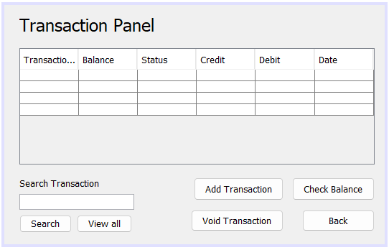

/*

* To change this license header, choose License Headers in Project Properties.

* To change this template file, choose Tools | Templates

* and open the template in the editor.

*/

package GenBank;

import java.awt.*;

import java.awt.event.*;

import javax.sql.rowset.spi.TransactionalWriter;

import javax.swing.*;

import javax.swing.table.DefaultTableModel;

import java.sql.*;

/**

*

* @author ssuish

*/

public class ViewTransaction extends javax.swing.JFrame {

/**

* Creates new form ViewTransaction

*/

public ViewTransaction() {

initComponents();

}

/**

* This method is called from within the constructor to initialize the form.

* WARNING: Do NOT modify this code. The content of this method is always

* regenerated by the Form Editor.

*/

@SuppressWarnings("unchecked")

// <editor-fold defaultstate="collapsed" desc="Generated Code">

private void initComponents() {

jLabel1 = new javax.swing.JLabel();

jScrollPane1 = new javax.swing.JScrollPane();

transactTbl = new javax.swing.JTable();

btnSearch = new javax.swing.JButton();

btnAddTransaction = new javax.swing.JButton();

btnCheckBalance = new javax.swing.JButton();

btnVoidTransaction = new javax.swing.JButton();

btnBack = new javax.swing.JButton();

jLabel2 = new javax.swing.JLabel();

jTextField1 = new javax.swing.JTextField();

btnViewAll = new javax.swing.JButton();

setDefaultCloseOperation(javax.swing.WindowConstants.EXIT_ON_CLOSE);

jLabel1.setFont(new java.awt.Font("Tahoma", 0, 24)); // NOI18N

jLabel1.setText("Transaction Panel");

transactTbl.setModel(new javax.swing.table.DefaultTableModel(

new Object [][] {

{null, null, null, null, null, null},

{null, null, null, null, null, null},

{null, null, null, null, null, null},

{null, null, null, null, null, null}

},

new String [] {

"TransactionID", "Balance", "Status", "Credit", "Debit", "Date"

}

));

jScrollPane1.setViewportView(transactTbl);

btnSearch.setText("Search");

btnSearch.addActionListener(new java.awt.event.ActionListener() {

public void actionPerformed(java.awt.event.ActionEvent evt) {

btnSearchActionPerformed(evt);

}

});

btnAddTransaction.setText("Add Transaction");

btnAddTransaction.addActionListener(new java.awt.event.ActionListener() {

public void actionPerformed(java.awt.event.ActionEvent evt) {

btnAddTransactionActionPerformed(evt);

}

});

btnCheckBalance.setText("Check Balance");

btnCheckBalance.addActionListener(new java.awt.event.ActionListener() {

public void actionPerformed(java.awt.event.ActionEvent evt) {

btnCheckBalanceActionPerformed(evt);

}

});

btnVoidTransaction.setText("Void Transaction");

btnVoidTransaction.addActionListener(new java.awt.event.ActionListener() {

public void actionPerformed(java.awt.event.ActionEvent evt) {

btnVoidTransactionActionPerformed(evt);

}

});

btnBack.setText("Back");

btnBack.addActionListener(new java.awt.event.ActionListener() {

public void actionPerformed(java.awt.event.ActionEvent evt) {

btnBackActionPerformed(evt);

}

});

jLabel2.setText("Search Transaction");

btnViewAll.setText("View all");

btnViewAll.addActionListener(new java.awt.event.ActionListener() {

public void actionPerformed(java.awt.event.ActionEvent evt) {

btnViewAllActionPerformed(evt);

}

});

javax.swing.GroupLayout layout = new javax.swing.GroupLayout(getContentPane());

getContentPane().setLayout(layout);

layout.setHorizontalGroup(

layout.createParallelGroup(javax.swing.GroupLayout.Alignment.LEADING)

.addGroup(layout.createSequentialGroup()

.addGap(21, 21, 21)

.addGroup(layout.createParallelGroup(javax.swing.GroupLayout.Alignment.LEADING, false)

.addComponent(jLabel1)

.addComponent(jScrollPane1, javax.swing.GroupLayout.PREFERRED_SIZE, 495, javax.swing.GroupLayout.PREFERRED_SIZE)

.addGroup(javax.swing.GroupLayout.Alignment.TRAILING, layout.createSequentialGroup()

.addGroup(layout.createParallelGroup(javax.swing.GroupLayout.Alignment.LEADING)

.addComponent(jTextField1)

.addGroup(layout.createSequentialGroup()

.addGroup(layout.createParallelGroup(javax.swing.GroupLayout.Alignment.LEADING)

.addComponent(jLabel2)

.addGroup(layout.createSequentialGroup()

.addComponent(btnSearch)

.addPreferredGap(javax.swing.LayoutStyle.ComponentPlacement.RELATED)

.addComponent(btnViewAll)))

.addGap(0, 0, Short.MAX_VALUE)))

.addGap(79, 79, 79)

.addGroup(layout.createParallelGroup(javax.swing.GroupLayout.Alignment.TRAILING)

.addComponent(btnAddTransaction)

.addComponent(btnVoidTransaction))

.addPreferredGap(javax.swing.LayoutStyle.ComponentPlacement.UNRELATED)

.addGroup(layout.createParallelGroup(javax.swing.GroupLayout.Alignment.TRAILING)

.addComponent(btnCheckBalance)

.addComponent(btnBack, javax.swing.GroupLayout.PREFERRED_SIZE, 101, javax.swing.GroupLayout.PREFERRED_SIZE))))

.addContainerGap(14, Short.MAX_VALUE))

);

layout.setVerticalGroup(

layout.createParallelGroup(javax.swing.GroupLayout.Alignment.LEADING)

.addGroup(javax.swing.GroupLayout.Alignment.TRAILING, layout.createSequentialGroup()

.addContainerGap()

.addComponent(jLabel1)

.addGap(18, 18, 18)

.addComponent(jScrollPane1, javax.swing.GroupLayout.PREFERRED_SIZE, 162, javax.swing.GroupLayout.PREFERRED_SIZE)

.addGap(18, 18, 18)

.addGroup(layout.createParallelGroup(javax.swing.GroupLayout.Alignment.LEADING)

.addGroup(layout.createSequentialGroup()

.addComponent(jLabel2)

.addPreferredGap(javax.swing.LayoutStyle.ComponentPlacement.RELATED)

.addComponent(jTextField1, javax.swing.GroupLayout.PREFERRED_SIZE, javax.swing.GroupLayout.DEFAULT_SIZE, javax.swing.GroupLayout.PREFERRED_SIZE)

.addPreferredGap(javax.swing.LayoutStyle.ComponentPlacement.RELATED)

.addGroup(layout.createParallelGroup(javax.swing.GroupLayout.Alignment.BASELINE)

.addComponent(btnSearch)

.addComponent(btnViewAll)))

.addGroup(layout.createSequentialGroup()

.addGroup(layout.createParallelGroup(javax.swing.GroupLayout.Alignment.BASELINE)

.addComponent(btnAddTransaction, javax.swing.GroupLayout.PREFERRED_SIZE, 32, javax.swing.GroupLayout.PREFERRED_SIZE)

.addComponent(btnCheckBalance, javax.swing.GroupLayout.PREFERRED_SIZE, 32, javax.swing.GroupLayout.PREFERRED_SIZE))

.addPreferredGap(javax.swing.LayoutStyle.ComponentPlacement.UNRELATED)

.addGroup(layout.createParallelGroup(javax.swing.GroupLayout.Alignment.BASELINE)

.addComponent(btnVoidTransaction, javax.swing.GroupLayout.PREFERRED_SIZE, 30, javax.swing.GroupLayout.PREFERRED_SIZE)

.addComponent(btnBack, javax.swing.GroupLayout.PREFERRED_SIZE, 30, javax.swing.GroupLayout.PREFERRED_SIZE))))

.addContainerGap(16, Short.MAX_VALUE))

);

pack();

}// </editor-fold>

private void btnBackActionPerformed(java.awt.event.ActionEvent evt) {

// TODO add your handling code here:

this.setVisible(false);

MainPage mainpg = new MainPage();

mainpg.setVisible(true);

}

private void btnViewAllActionPerformed(java.awt.event.ActionEvent evt) {

// TODO add your handling code here:

// database connection from javadb

try {

Class.forName("org.apache.derby.jdbc.ClientDriver");

Connection con = DriverManager.getConnection("jdbc:derby://localhost:1527/BankingSystem", "admin123", "12345678");

Statement stmt = con.createStatement();

String sql = "select transactionId, balance, status, credit, debit, date from transactiontbl";

ResultSet rs = stmt.executeQuery(sql);

DefaultTableModel model = (DefaultTableModel) transactTbl.getModel();

model.setRowCount(0);

while (rs.next()) {

String id = rs.getString("transactionId");

String balance = rs.getString("balance");

String status = rs.getString("status");

String credit = rs.getString("credit");

String debit = rs.getString("debit");

String date = rs.getString("date");

String tbData[] = {id, balance, status, credit, debit, date};

DefaultTableModel tblModel = (DefaultTableModel) transactTbl.getModel();

tblModel.addRow(tbData);

}

con.close();

} catch (Exception e) {

System.out.println(e);

}

}

private void btnSearchActionPerformed(java.awt.event.ActionEvent evt) {

// TODO add your handling code here:

// database connection from javadb and search transaction

try {

Class.forName("org.apache.derby.jdbc.ClientDriver");

Connection con = DriverManager.getConnection("jdbc:derby://localhost:1527/BankingSystem", "admin123", "12345678");

Statement stmt = con.createStatement();

String sql = "select transactionId, balance, status, credit, debit, date from transactiontbl where transactionId = " + jTextField1.getText() + "";

ResultSet rs = stmt.executeQuery(sql);

DefaultTableModel model = (DefaultTableModel) transactTbl.getModel();

model.setRowCount(0);

while (rs.next()) {

String id = rs.getString("transactionId");

String balance = rs.getString("balance");

String status = rs.getString("status");

String credit = rs.getString("credit");

String debit = rs.getString("debit");

String date = rs.getString("date");

String tbData[] = {id, balance, status, credit, debit, date};

DefaultTableModel tblModel = (DefaultTableModel) transactTbl.getModel();

tblModel.addRow(tbData);

}

con.close();

} catch (Exception e) {

System.out.println(e);

}

}

private void btnCheckBalanceActionPerformed(java.awt.event.ActionEvent evt) {

// TODO add your handling code here:

this.setVisible(false);

CheckBalance chkbal = new CheckBalance();

chkbal.setVisible(true);

}

private void btnAddTransactionActionPerformed(java.awt.event.ActionEvent evt) {

// TODO add your handling code here:

this.setVisible(false);

PayBills paybill = new PayBills();

paybill.setVisible(true);

}

private void btnVoidTransactionActionPerformed(java.awt.event.ActionEvent evt) {

// TODO add your handling code here:

// database connection from javadb and delete selected row

try {

Class.forName("org.apache.derby.jdbc.ClientDriver");

Connection con = DriverManager.getConnection("jdbc:derby://localhost:1527/BankingSystem", "admin123", "12345678");

Statement stmt = con.createStatement();

String sql = "delete from transactiontbl where transactionId = " + transactTbl.getValueAt(transactTbl.getSelectedRow(), 0);

stmt.executeUpdate(sql);

con.close();

JOptionPane.showMessageDialog(null, "Transaction Deleted");

} catch (Exception e) {

System.out.println(e);

}

}

/**

* @param args the command line arguments

*/

public static void main(String args[]) {

/* Set the Nimbus look and feel */

//<editor-fold defaultstate="collapsed" desc=" Look and feel setting code (optional) ">

/* If Nimbus (introduced in Java SE 6) is not available, stay with the default look and feel.

* For details see http://download.oracle.com/javase/tutorial/uiswing/lookandfeel/plaf.html

*/

try {

for (javax.swing.UIManager.LookAndFeelInfo info : javax.swing.UIManager.getInstalledLookAndFeels()) {

if ("Nimbus".equals(info.getName())) {

javax.swing.UIManager.setLookAndFeel(info.getClassName());

break;

}

}

} catch (ClassNotFoundException ex) {

java.util.logging.Logger.getLogger(ViewTransaction.class.getName()).log(java.util.logging.Level.SEVERE, null, ex);

} catch (InstantiationException ex) {

java.util.logging.Logger.getLogger(ViewTransaction.class.getName()).log(java.util.logging.Level.SEVERE, null, ex);

} catch (IllegalAccessException ex) {

java.util.logging.Logger.getLogger(ViewTransaction.class.getName()).log(java.util.logging.Level.SEVERE, null, ex);

} catch (javax.swing.UnsupportedLookAndFeelException ex) {

java.util.logging.Logger.getLogger(ViewTransaction.class.getName()).log(java.util.logging.Level.SEVERE, null, ex);

}

//</editor-fold>

/* Create and display the form */

java.awt.EventQueue.invokeLater(new Runnable() {

public void run() {

new ViewTransaction().setVisible(true);

}

});

}

// Variables declaration - do not modify

private javax.swing.JButton btnAddTransaction;

private javax.swing.JButton btnBack;

private javax.swing.JButton btnCheckBalance;

private javax.swing.JButton btnSearch;

private javax.swing.JButton btnViewAll;

private javax.swing.JButton btnVoidTransaction;

private javax.swing.JLabel jLabel1;

private javax.swing.JLabel jLabel2;

private javax.swing.JScrollPane jScrollPane1;

private javax.swing.JTextField jTextField1;

private javax.swing.JTable transactTbl;

// End of variables declaration

}

**ViewAccount.java**

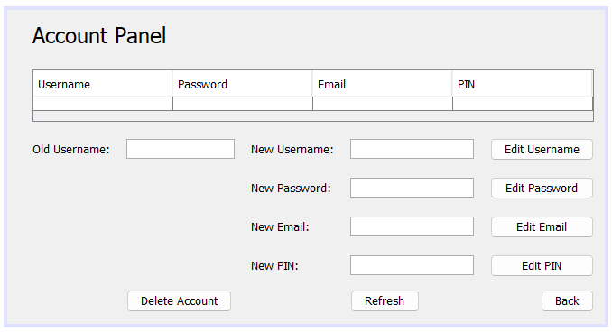`

/*

* To change this license header, choose License Headers in Project Properties.

* To change this template file, choose Tools | Templates

* and open the template in the editor.

*/

package GenBank;

import java.sql.*;

import javax.swing.JOptionPane;

import javax.swing.table.DefaultTableModel;

/**

*

* @author ssuish

*/

public class ViewAccount extends javax.swing.JFrame {

/**

* Creates new form ViewAccount

*/

public ViewAccount() {

initComponents();

}

/**

* This method is called from within the constructor to initialize the form.

* WARNING: Do NOT modify this code. The content of this method is always

* regenerated by the Form Editor.

*/

@SuppressWarnings("unchecked")

// <editor-fold defaultstate="collapsed" desc="Generated

// Code">

private void initComponents() {

jLabel1 = new javax.swing.JLabel();

jScrollPane2 = new javax.swing.JScrollPane();

jTable2 = new javax.swing.JTable();

jLabel2 = new javax.swing.JLabel();

txtOdUsername = new javax.swing.JTextField();

jLabel6 = new javax.swing.JLabel();

jLabel7 = new javax.swing.JLabel();

jLabel8 = new javax.swing.JLabel();

jLabel9 = new javax.swing.JLabel();

txtNwUsername = new javax.swing.JTextField();

txtNwEmail = new javax.swing.JTextField();

btnDelAccount = new javax.swing.JButton();

btnUsername = new javax.swing.JButton();

editPassword = new javax.swing.JButton();

editEmail = new javax.swing.JButton();

editPIN = new javax.swing.JButton();

btnBack = new javax.swing.JButton();

txtNwPassword = new javax.swing.JPasswordField();

txtNwPIN = new javax.swing.JPasswordField();

btnRefresh = new javax.swing.JButton();

setDefaultCloseOperation(javax.swing.WindowConstants.EXIT_ON_CLOSE);

jLabel1.setFont(new java.awt.Font("Tahoma", 0, 24)); // NOI18N

jLabel1.setText("Account Panel");

jTable2.setModel(new javax.swing.table.DefaultTableModel(

new Object[][] {

{ null, null, null, null }

},

new String[] {

"Username", "Password", "Email", "PIN"

}));

jScrollPane2.setViewportView(jTable2);

jLabel2.setText("Old Username:");

jLabel6.setText("New Username:");

jLabel7.setText("New Password:");

jLabel8.setText("New Email:");

jLabel9.setText("New PIN:");

btnDelAccount.setText("Delete Account");

btnDelAccount.addActionListener(new java.awt.event.ActionListener() {

public void actionPerformed(java.awt.event.ActionEvent evt) {

btnDelAccountActionPerformed(evt);

}

});

btnUsername.setText("Edit Username");

btnUsername.addActionListener(new java.awt.event.ActionListener() {

public void actionPerformed(java.awt.event.ActionEvent evt) {

btnUsernameActionPerformed(evt);

}

});

editPassword.setText("Edit Password");

editPassword.addActionListener(new java.awt.event.ActionListener() {

public void actionPerformed(java.awt.event.ActionEvent evt) {

editPasswordActionPerformed(evt);

}

});

editEmail.setText("Edit Email");

editEmail.addActionListener(new java.awt.event.ActionListener() {

public void actionPerformed(java.awt.event.ActionEvent evt) {

editEmailActionPerformed(evt);

}

});

editPIN.setText("Edit PIN");

editPIN.addActionListener(new java.awt.event.ActionListener() {

public void actionPerformed(java.awt.event.ActionEvent evt) {

editPINActionPerformed(evt);

}

});

btnBack.setText("Back");

btnBack.addActionListener(new java.awt.event.ActionListener() {

public void actionPerformed(java.awt.event.ActionEvent evt) {

btnBackActionPerformed(evt);

}

});

btnRefresh.setText("Refresh");

btnRefresh.addActionListener(new java.awt.event.ActionListener() {

public void actionPerformed(java.awt.event.ActionEvent evt) {

btnRefreshActionPerformed(evt);

}

});

javax.swing.GroupLayout layout = new javax.swing.GroupLayout(getContentPane());

getContentPane().setLayout(layout);

layout.setHorizontalGroup(

layout.createParallelGroup(javax.swing.GroupLayout.Alignment.LEADING)

.addGroup(layout.createSequentialGroup()

.addGap(28, 28, 28)

.addGroup(layout.createParallelGroup(javax.swing.GroupLayout.Alignment.LEADING)

.addComponent(jScrollPane2, javax.swing.GroupLayout.Alignment.TRAILING)

.addGroup(layout.createSequentialGroup()

.addGroup(layout

.createParallelGroup(javax.swing.GroupLayout.Alignment.LEADING)

.addComponent(jLabel1)

.addGroup(layout.createSequentialGroup()

.addComponent(jLabel2)

.addGap(18, 18, 18)

.addGroup(layout.createParallelGroup(

javax.swing.GroupLayout.Alignment.LEADING)

.addGroup(layout.createSequentialGroup()

.addComponent(txtOdUsername,

javax.swing.GroupLayout.PREFERRED_SIZE,

120,

javax.swing.GroupLayout.PREFERRED_SIZE)

.addGap(18, 18, 18)

.addGroup(layout.createParallelGroup(

javax.swing.GroupLayout.Alignment.LEADING)

.addComponent(jLabel6)

.addComponent(jLabel7)

.addComponent(jLabel8)

.addComponent(jLabel9)))

.addComponent(btnDelAccount))

.addGap(18, 18, 18)

.addGroup(layout.createParallelGroup(

javax.swing.GroupLayout.Alignment.LEADING,

false)

.addGroup(layout.createSequentialGroup()

.addComponent(btnRefresh)

.addGap(0, 60, Short.MAX_VALUE))

.addComponent(txtNwUsername)

.addComponent(txtNwEmail,

javax.swing.GroupLayout.Alignment.TRAILING)

.addComponent(txtNwPassword)

.addComponent(txtNwPIN,

javax.swing.GroupLayout.Alignment.TRAILING))

.addGap(18, 18, 18)

.addGroup(layout.createParallelGroup(

javax.swing.GroupLayout.Alignment.LEADING,

false)

.addComponent(btnUsername,

javax.swing.GroupLayout.DEFAULT_SIZE,

javax.swing.GroupLayout.DEFAULT_SIZE,

Short.MAX_VALUE)

.addComponent(editPassword,

javax.swing.GroupLayout.DEFAULT_SIZE,

javax.swing.GroupLayout.DEFAULT_SIZE,

Short.MAX_VALUE)

.addComponent(editEmail,

javax.swing.GroupLayout.DEFAULT_SIZE,

javax.swing.GroupLayout.DEFAULT_SIZE,

Short.MAX_VALUE)

.addComponent(editPIN,

javax.swing.GroupLayout.DEFAULT_SIZE,

javax.swing.GroupLayout.DEFAULT_SIZE,

Short.MAX_VALUE)

.addComponent(btnBack,

javax.swing.GroupLayout.Alignment.TRAILING))))

.addGap(0, 0, Short.MAX_VALUE)))

.addContainerGap()));

layout.setVerticalGroup(

layout.createParallelGroup(javax.swing.GroupLayout.Alignment.LEADING)

.addGroup(javax.swing.GroupLayout.Alignment.TRAILING, layout.createSequentialGroup()

.addContainerGap()

.addComponent(jLabel1)

.addGap(24, 24, 24)

.addComponent(jScrollPane2, javax.swing.GroupLayout.PREFERRED_SIZE, 58,

javax.swing.GroupLayout.PREFERRED_SIZE)

.addGap(18, 18, 18)

.addGroup(layout.createParallelGroup(javax.swing.GroupLayout.Alignment.BASELINE)

.addComponent(jLabel2)

.addComponent(txtOdUsername, javax.swing.GroupLayout.PREFERRED_SIZE,

javax.swing.GroupLayout.DEFAULT_SIZE,

javax.swing.GroupLayout.PREFERRED_SIZE)

.addComponent(jLabel6)

.addComponent(txtNwUsername, javax.swing.GroupLayout.PREFERRED_SIZE,

javax.swing.GroupLayout.DEFAULT_SIZE,

javax.swing.GroupLayout.PREFERRED_SIZE)

.addComponent(btnUsername))

.addGap(18, 18, 18)

.addGroup(layout.createParallelGroup(javax.swing.GroupLayout.Alignment.BASELINE)

.addComponent(jLabel7)

.addComponent(editPassword)

.addComponent(txtNwPassword, javax.swing.GroupLayout.PREFERRED_SIZE,

javax.swing.GroupLayout.DEFAULT_SIZE,

javax.swing.GroupLayout.PREFERRED_SIZE))

.addGap(18, 18, 18)

.addGroup(layout.createParallelGroup(javax.swing.GroupLayout.Alignment.BASELINE)

.addComponent(jLabel8)

.addComponent(txtNwEmail, javax.swing.GroupLayout.PREFERRED_SIZE,

javax.swing.GroupLayout.DEFAULT_SIZE,

javax.swing.GroupLayout.PREFERRED_SIZE)

.addComponent(editEmail))

.addGap(18, 18, 18)

.addGroup(layout.createParallelGroup(javax.swing.GroupLayout.Alignment.BASELINE)

.addComponent(jLabel9)

.addComponent(editPIN)

.addComponent(txtNwPIN, javax.swing.GroupLayout.PREFERRED_SIZE,

javax.swing.GroupLayout.DEFAULT_SIZE,

javax.swing.GroupLayout.PREFERRED_SIZE))

.addPreferredGap(javax.swing.LayoutStyle.ComponentPlacement.RELATED, 14,

Short.MAX_VALUE)

.addGroup(layout.createParallelGroup(javax.swing.GroupLayout.Alignment.BASELINE)

.addComponent(btnDelAccount)

.addComponent(btnBack)

.addComponent(btnRefresh))

.addContainerGap()));

pack();

}// </editor-fold>

private void btnBackActionPerformed(java.awt.event.ActionEvent evt) {// GEN-FIRST:event_btnBackActionPerformed

// TODO add your handling code here:

MainPage pg = new MainPage();

this.setVisible(false);

pg.setVisible(true);

}// GEN-LAST:event_btnBackActionPerformed

private void btnUsernameActionPerformed(java.awt.event.ActionEvent evt) {// GEN-FIRST:event_btnUsernameActionPerformed

// TODO add your handling code here:

// database connecton java db

try {

// check if username is empty

if (txtNwUsername.getText().isEmpty()) {

JOptionPane.showMessageDialog(null, "Please enter a username");

} else {

Class.forName("org.apache.derby.jdbc.ClientDriver");

Connection con = DriverManager.getConnection("jdbc:derby://localhost:1527/BankingSystem", "admin123",

"12345678");

Statement stmt = con.createStatement();

String query = "UPDATE usertbl SET USERNAME = '" + txtNwUsername.getText() + "' WHERE USERNAME = '"

+ txtOdUsername.getText() + "'";

stmt.executeUpdate(query);

JOptionPane.showMessageDialog(null, "Username Updated Successfully");

txtOdUsername.setText(txtNwUsername.getText());

txtNwUsername.setText("");

con.close();

}

} catch (Exception e) {

JOptionPane.showMessageDialog(null, e);

}

}// GEN-LAST:event_btnUsernameActionPerformed

private void editPasswordActionPerformed(java.awt.event.ActionEvent evt) {// GEN-FIRST:event_editPasswordActionPerformed

// TODO add your handling code here:

// database connecton java db

char[] passN = txtNwPassword.getPassword();

String passwordN = String.copyValueOf(passN);

try {

// check if password is empty

if (passwordN.isEmpty()) {

JOptionPane.showMessageDialog(null, "Please enter a password");

} else {

Class.forName("org.apache.derby.jdbc.ClientDriver");

Connection con = DriverManager.getConnection("jdbc:derby://localhost:1527/BankingSystem", "admin123",

"12345678");

Statement stmt = con.createStatement();

String query = "UPDATE usertbl SET PASSWORD = '" + passwordN + "' WHERE USERNAME = '"

+ txtOdUsername.getText() + "'";

stmt.executeUpdate(query);

JOptionPane.showMessageDialog(null, "Password Updated Successfully");

txtNwPassword.setText("");

con.close();

}

} catch (Exception e) {

JOptionPane.showMessageDialog(null, e);

}

}// GEN-LAST:event_editPasswordActionPerformed

private void editEmailActionPerformed(java.awt.event.ActionEvent evt) {// GEN-FIRST:event_editEmailActionPerformed

// TODO add your handling code here:

String username = txtOdUsername.getText();

// database connecton java db

try {

// check if email is empty

if (txtNwEmail.getText().isEmpty()) {

JOptionPane.showMessageDialog(null, "Please enter an email");

} else {

Class.forName("org.apache.derby.jdbc.ClientDriver");

Connection con = DriverManager.getConnection("jdbc:derby://localhost:1527/BankingSystem", "admin123",

"12345678");

Statement stmt = con.createStatement();

String query = "UPDATE usertbl SET EMAIL = '" + txtNwEmail.getText() + "' WHERE USERNAME = '" + username

+ "'";

stmt.executeUpdate(query);

JOptionPane.showMessageDialog(null, "Email Updated Successfully");

txtNwEmail.setText("");

con.close();

}

} catch (Exception e) {

JOptionPane.showMessageDialog(null, e);

}

}// GEN-LAST:event_editEmailActionPerformed

private void editPINActionPerformed(java.awt.event.ActionEvent evt) {// GEN-FIRST:event_editPINActionPerformed

// TODO add your handling code here:

// database connecton java db

char[] passN = txtNwPIN.getPassword();

String passpinN = String.copyValueOf(passN);

String username = txtOdUsername.getText();

try {

// check if password is empty

if (passpinN.isEmpty()) {

JOptionPane.showMessageDialog(null, "Please enter a password");

} else {

Class.forName("org.apache.derby.jdbc.ClientDriver");

Connection con = DriverManager.getConnection("jdbc:derby://localhost:1527/BankingSystem", "admin123",

"12345678");

Statement stmt = con.createStatement();

String query = "UPDATE usertbl SET PIN = '" + passpinN + "' WHERE username = '" + username + "'";

stmt.executeUpdate(query);

JOptionPane.showMessageDialog(null, "Password Updated Successfully");

txtNwPassword.setText("");

con.close();

}

} catch (Exception e) {

JOptionPane.showMessageDialog(null, e);

}

}// GEN-LAST:event_editPINActionPerformed

private void btnDelAccountActionPerformed(java.awt.event.ActionEvent evt) {// GEN-FIRST:event_btnDelAccountActionPerformed

// TODO add your handling code here:

// database connecton java db

String username = txtNwUsername.getText();

try {

Class.forName("org.apache.derby.jdbc.ClientDriver");

Connection con = DriverManager.getConnection("jdbc:derby://localhost:1527/BankingSystem", "admin123",

"12345678");

Statement stmt = con.createStatement();

String query0 = "select username from usertbl where username = '" + txtOdUsername.getText() + "'";

ResultSet rs = stmt.executeQuery(query0);

while (rs.next()) {

username = rs.getString("username");

}

String query = "DELETE FROM usertbl WHERE USERNAME = '" + username + "'";

stmt.executeUpdate(query);

JOptionPane.showMessageDialog(null, "Account Deleted Successfully");

con.close();

this.dispose();

UserLogin userlogin = new UserLogin();

userlogin.setVisible(true);

} catch (Exception e) {

JOptionPane.showMessageDialog(null, e);

}

}// GEN-LAST:event_btnDelAccountActionPerformed

private void btnRefreshActionPerformed(java.awt.event.ActionEvent evt) {// GEN-FIRST:event_btnRefreshActionPerformed

// TODO add your handling code here:

// database connecton java db populate table

try {

Class.forName("org.apache.derby.jdbc.ClientDriver");

Connection con = DriverManager.getConnection("jdbc:derby://localhost:1527/BankingSystem", "admin123",

"12345678");

Statement stmt = con.createStatement();

String query = "select * from usertbl";

ResultSet rs = stmt.executeQuery(query);

DefaultTableModel model = (DefaultTableModel) jTable2.getModel();

model.setRowCount(0);

while (rs.next()) {

model.addRow(new Object[] { rs.getString("username"), rs.getString("password"), rs.getString("email"),

rs.getString("pin") });

}

con.close();

} catch (Exception e) {

JOptionPane.showMessageDialog(null, e);

}

}// GEN-LAST:event_btnRefreshActionPerformed

/**

* @param args the command line arguments

*/

public static void main(String args[]) {

/* Set the Nimbus look and feel */

// <editor-fold defaultstate="collapsed" desc=" Look and feel setting code

// (optional) ">

/*

* If Nimbus (introduced in Java SE 6) is not available, stay with the default

* look and feel.

* For details see

* http://download.oracle.com/javase/tutorial/uiswing/lookandfeel/plaf.html

*/

try {

for (javax.swing.UIManager.LookAndFeelInfo info : javax.swing.UIManager.getInstalledLookAndFeels()) {

if ("Nimbus".equals(info.getName())) {

javax.swing.UIManager.setLookAndFeel(info.getClassName());

break;

}

}

} catch (ClassNotFoundException ex) {

java.util.logging.Logger.getLogger(ViewAccount.class.getName()).log(java.util.logging.Level.SEVERE, null,

ex);

} catch (InstantiationException ex) {

java.util.logging.Logger.getLogger(ViewAccount.class.getName()).log(java.util.logging.Level.SEVERE, null,

ex);

} catch (IllegalAccessException ex) {

java.util.logging.Logger.getLogger(ViewAccount.class.getName()).log(java.util.logging.Level.SEVERE, null,

ex);

} catch (javax.swing.UnsupportedLookAndFeelException ex) {

java.util.logging.Logger.getLogger(ViewAccount.class.getName()).log(java.util.logging.Level.SEVERE, null,

ex);

}

// </editor-fold>

/* Create and display the form */

java.awt.EventQueue.invokeLater(new Runnable() {

public void run() {

new ViewAccount().setVisible(true);

}

});

}

// Variables declaration - do not modify

private javax.swing.JButton btnBack;

private javax.swing.JButton btnDelAccount;

private javax.swing.JButton btnRefresh;

private javax.swing.JButton btnUsername;

private javax.swing.JButton editEmail;

private javax.swing.JButton editPIN;

private javax.swing.JButton editPassword;

private javax.swing.JLabel jLabel1;

private javax.swing.JLabel jLabel2;

private javax.swing.JLabel jLabel6;

private javax.swing.JLabel jLabel7;

private javax.swing.JLabel jLabel8;

private javax.swing.JLabel jLabel9;

private javax.swing.JScrollPane jScrollPane2;

private javax.swing.JTable jTable2;

private javax.swing.JTextField txtNwEmail;

private javax.swing.JPasswordField txtNwPIN;

private javax.swing.JPasswordField txtNwPassword;

private javax.swing.JTextField txtNwUsername;

private javax.swing.JTextField txtOdUsername;

// End of variables declaration

}

**CheckBalance.java**

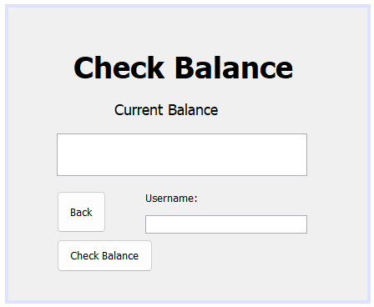

/*

* To change this license header, choose License Headers in Project Properties.

* To change this template file, choose Tools | Templates

* and open the template in the editor.

*/

package GenBank;

import java.sql.*;

import javax.swing.JOptionPane;

/**

*

* @author ssuish

*/

public class CheckBalance extends javax.swing.JFrame {

/**

* Creates new form CheckBalance

*/

public CheckBalance() {

initComponents();

}

/**

* This method is called from within the constructor to initialize the form.

* WARNING: Do NOT modify this code. The content of this method is always

* regenerated by the Form Editor.

*/

@SuppressWarnings("unchecked")

// <editor-fold defaultstate="collapsed" desc="Generated Code">

private void initComponents() {

jLabel2 = new javax.swing.JLabel();

jLabel1 = new javax.swing.JLabel();

balance = new javax.swing.JTextField();

btnBack = new javax.swing.JButton();

transactionID = new javax.swing.JLabel();

username = new javax.swing.JTextField();

jButton1 = new javax.swing.JButton();

setDefaultCloseOperation(javax.swing.WindowConstants.EXIT_ON_CLOSE);

jLabel2.setFont(new java.awt.Font("Tahoma", 1, 36)); // NOI18N

jLabel2.setText("Check Balance");

jLabel1.setFont(new java.awt.Font("Tahoma", 0, 18)); // NOI18N

jLabel1.setText("Current Balance");

balance.addActionListener(new java.awt.event.ActionListener() {

public void actionPerformed(java.awt.event.ActionEvent evt) {

balanceActionPerformed(evt);

}

});

btnBack.setText("Back");

btnBack.addActionListener(new java.awt.event.ActionListener() {

public void actionPerformed(java.awt.event.ActionEvent evt) {

btnBackActionPerformed(evt);

}

});

transactionID.setText("Username:");

jButton1.setText("Check Balance");

jButton1.addActionListener(new java.awt.event.ActionListener() {

public void actionPerformed(java.awt.event.ActionEvent evt) {

jButton1ActionPerformed(evt);

}

});

javax.swing.GroupLayout layout = new javax.swing.GroupLayout(getContentPane());

getContentPane().setLayout(layout);

layout.setHorizontalGroup(

layout.createParallelGroup(javax.swing.GroupLayout.Alignment.LEADING)

.addGroup(layout.createSequentialGroup()

.addGroup(layout.createParallelGroup(javax.swing.GroupLayout.Alignment.LEADING)

.addGroup(layout.createSequentialGroup()

.addGap(127, 127, 127)

.addComponent(jLabel1))

.addGroup(layout.createSequentialGroup()

.addGap(58, 58, 58)

.addGroup(layout.createParallelGroup(javax.swing.GroupLayout.Alignment.LEADING, false)

.addGroup(layout.createSequentialGroup()

.addComponent(btnBack)

.addGap(47, 47, 47)

.addGroup(layout.createParallelGroup(javax.swing.GroupLayout.Alignment.LEADING)

.addComponent(transactionID)

.addComponent(username)))

.addComponent(balance, javax.swing.GroupLayout.PREFERRED_SIZE, 300, javax.swing.GroupLayout.PREFERRED_SIZE)

.addComponent(jButton1)))

.addGroup(layout.createSequentialGroup()

.addGap(78, 78, 78)

.addComponent(jLabel2)))

.addContainerGap(72, Short.MAX_VALUE))

);

layout.setVerticalGroup(

layout.createParallelGroup(javax.swing.GroupLayout.Alignment.LEADING)

.addGroup(layout.createSequentialGroup()

.addGap(49, 49, 49)

.addComponent(jLabel2)

.addGap(18, 18, 18)

.addComponent(jLabel1)

.addGap(18, 18, 18)

.addComponent(balance, javax.swing.GroupLayout.PREFERRED_SIZE, 51, javax.swing.GroupLayout.PREFERRED_SIZE)

.addGap(18, 18, 18)

.addGroup(layout.createParallelGroup(javax.swing.GroupLayout.Alignment.LEADING)

.addComponent(btnBack, javax.swing.GroupLayout.PREFERRED_SIZE, 50, javax.swing.GroupLayout.PREFERRED_SIZE)

.addGroup(layout.createSequentialGroup()

.addComponent(transactionID)

.addPreferredGap(javax.swing.LayoutStyle.ComponentPlacement.UNRELATED)

.addComponent(username, javax.swing.GroupLayout.PREFERRED_SIZE, javax.swing.GroupLayout.DEFAULT_SIZE, javax.swing.GroupLayout.PREFERRED_SIZE)))

.addPreferredGap(javax.swing.LayoutStyle.ComponentPlacement.RELATED)

.addComponent(jButton1, javax.swing.GroupLayout.PREFERRED_SIZE, 39, javax.swing.GroupLayout.PREFERRED_SIZE)

.addContainerGap(34, Short.MAX_VALUE))

);

pack();

}// </editor-fold>

private void btnBackActionPerformed(java.awt.event.ActionEvent evt) {

// TODO add your handling code here:

this.setVisible(false);

MainPage mainpg = new MainPage();

mainpg.setVisible(true);

}

private void jButton1ActionPerformed(java.awt.event.ActionEvent evt) {

// TODO add your handling code here:

String sql2 = "select balance from transactiontbl join usertbl on transactiontbl.transactionID = usertbl.transactionID where usertbl.username = '" + username.getText() + "' order by transactiontbl.transactionID desc";

try {

Class.forName("org.apache.derby.jdbc.ClientDriver");

Connection con = DriverManager.getConnection("jdbc:derby://localhost:1527/BankingSystem", "admin123", "12345678");

String tid = transactionID.getText();

Statement pstmt = con.createStatement();

pstmt.execute(sql2);

ResultSet rs = pstmt.getResultSet();

if (rs.next()) {

double Balance = rs.getDouble("balance");

// Append the balance value to the balanceTextPane

balance.setText(balance.getText() + "Balance: " + Balance + "\n");

} else {

JOptionPane.showMessageDialog(null, "Transaction ID Not Found");

UserLogin UL = new UserLogin();

UL.setVisible(true);

this.dispose();

}

con.close();

} catch (Exception e) {

JOptionPane.showMessageDialog(null, e.getMessage());

}

}

private void balanceActionPerformed(java.awt.event.ActionEvent evt) {

// TODO add your handling code here:

}

/**

* @param args the command line arguments

*/

public static void main(String args[]) {

/* Set the Nimbus look and feel */

//<editor-fold defaultstate="collapsed" desc=" Look and feel setting code (optional) ">

/* If Nimbus (introduced in Java SE 6) is not available, stay with the default look and feel.

* For details see http://download.oracle.com/javase/tutorial/uiswing/lookandfeel/plaf.html

*/

try {

for (javax.swing.UIManager.LookAndFeelInfo info : javax.swing.UIManager.getInstalledLookAndFeels()) {

if ("Nimbus".equals(info.getName())) {

javax.swing.UIManager.setLookAndFeel(info.getClassName());

break;

}

}

} catch (ClassNotFoundException ex) {

java.util.logging.Logger.getLogger(CheckBalance.class.getName()).log(java.util.logging.Level.SEVERE, null, ex);

} catch (InstantiationException ex) {

java.util.logging.Logger.getLogger(CheckBalance.class.getName()).log(java.util.logging.Level.SEVERE, null, ex);

} catch (IllegalAccessException ex) {

java.util.logging.Logger.getLogger(CheckBalance.class.getName()).log(java.util.logging.Level.SEVERE, null, ex);

} catch (javax.swing.UnsupportedLookAndFeelException ex) {

java.util.logging.Logger.getLogger(CheckBalance.class.getName()).log(java.util.logging.Level.SEVERE, null, ex);

}

//</editor-fold>

/* Create and display the form */

java.awt.EventQueue.invokeLater(new Runnable() {

public void run() {

new CheckBalance().setVisible(true);

}

});

}

// Variables declaration - do not modify

private javax.swing.JTextField balance;

private javax.swing.JButton btnBack;

private javax.swing.JButton jButton1;

private javax.swing.JLabel jLabel1;

private javax.swing.JLabel jLabel2;

private javax.swing.JLabel transactionID;

private javax.swing.JTextField username;

// End of variables declaration

}

**Withdraw.java**

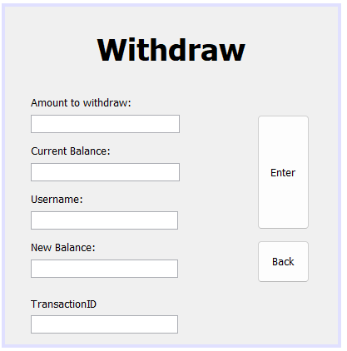

/*

* To change this license header, choose License Headers in Project Properties.

* To change this template file, choose Tools | Templates

* and open the template in the editor.

*/

package GenBank;

import java.sql.*;

import javax.swing.JOptionPane;

/**

*

* @author ssuish

*/

public class Withdraw extends javax.swing.JFrame {

/**

* Creates new form Withdraw

*/

public Withdraw() {

initComponents();

}

/**

* This method is called from within the constructor to initialize the form.

* WARNING: Do NOT modify this code. The content of this method is always

* regenerated by the Form Editor.

*/

@SuppressWarnings("unchecked")

// <editor-fold defaultstate="collapsed" desc="Generated Code">

private void initComponents() {

jLabel5 = new javax.swing.JLabel();

jLabel1 = new javax.swing.JLabel();

jLabel2 = new javax.swing.JLabel();

jTextField1 = new javax.swing.JTextField();

jLabel3 = new javax.swing.JLabel();

jTextField2 = new javax.swing.JTextField();

jLabel4 = new javax.swing.JLabel();

jTextField3 = new javax.swing.JTextField();

Withdraw = new javax.swing.JButton();

jButton2 = new javax.swing.JButton();

jTextField4 = new javax.swing.JTextField();

jLabel6 = new javax.swing.JLabel();

jLabel7 = new javax.swing.JLabel();

jTextField5 = new javax.swing.JTextField();

jLabel5.setText("jLabel5");

setDefaultCloseOperation(javax.swing.WindowConstants.EXIT_ON_CLOSE);

jLabel1.setFont(new java.awt.Font("Tahoma", 1, 36)); // NOI18N

jLabel1.setText("Withdraw");

jLabel2.setText("Amount to withdraw:");

jLabel3.setText("Current Balance:");

jLabel4.setText("New Balance:");

Withdraw.setText("Enter");

Withdraw.addActionListener(new java.awt.event.ActionListener() {

public void actionPerformed(java.awt.event.ActionEvent evt) {

WithdrawActionPerformed(evt);

}

});

jButton2.setText("Back");

jButton2.addActionListener(new java.awt.event.ActionListener() {

public void actionPerformed(java.awt.event.ActionEvent evt) {

jButton2ActionPerformed(evt);

}

});

jLabel6.setText("Username:");

jLabel7.setText("TransactionID");

javax.swing.GroupLayout layout = new javax.swing.GroupLayout(getContentPane());

getContentPane().setLayout(layout);

layout.setHorizontalGroup(

layout.createParallelGroup(javax.swing.GroupLayout.Alignment.LEADING)

.addGroup(layout.createSequentialGroup()

.addGap(110, 110, 110)

.addComponent(jLabel1)

.addContainerGap(111, Short.MAX_VALUE))

.addGroup(layout.createSequentialGroup()

.addGap(31, 31, 31)

.addGroup(layout.createParallelGroup(javax.swing.GroupLayout.Alignment.LEADING)

.addGroup(layout.createSequentialGroup()

.addGroup(layout.createParallelGroup(javax.swing.GroupLayout.Alignment.LEADING)

.addGroup(layout.createParallelGroup(javax.swing.GroupLayout.Alignment.LEADING, false)

.addComponent(jLabel3)

.addComponent(jLabel2)

.addComponent(jTextField1, javax.swing.GroupLayout.DEFAULT_SIZE, 179, Short.MAX_VALUE)

.addComponent(jTextField2))

.addComponent(jLabel4)

.addGroup(layout.createParallelGroup(javax.swing.GroupLayout.Alignment.TRAILING, false)

.addComponent(jLabel6, javax.swing.GroupLayout.Alignment.LEADING)

.addComponent(jTextField3, javax.swing.GroupLayout.Alignment.LEADING, javax.swing.GroupLayout.DEFAULT_SIZE, 177, Short.MAX_VALUE)

.addComponent(jTextField4)))

.addPreferredGap(javax.swing.LayoutStyle.ComponentPlacement.RELATED, javax.swing.GroupLayout.DEFAULT_SIZE, Short.MAX_VALUE)

.addGroup(layout.createParallelGroup(javax.swing.GroupLayout.Alignment.LEADING, false)

.addComponent(Withdraw, javax.swing.GroupLayout.DEFAULT_SIZE, javax.swing.GroupLayout.DEFAULT_SIZE, Short.MAX_VALUE)

.addComponent(jButton2, javax.swing.GroupLayout.DEFAULT_SIZE, javax.swing.GroupLayout.DEFAULT_SIZE, Short.MAX_VALUE))

.addGap(34, 34, 34))

.addGroup(layout.createSequentialGroup()

.addGroup(layout.createParallelGroup(javax.swing.GroupLayout.Alignment.LEADING)

.addComponent(jLabel7)

.addComponent(jTextField5, javax.swing.GroupLayout.PREFERRED_SIZE, 177, javax.swing.GroupLayout.PREFERRED_SIZE))

.addContainerGap(javax.swing.GroupLayout.DEFAULT_SIZE, Short.MAX_VALUE))))

);

layout.setVerticalGroup(

layout.createParallelGroup(javax.swing.GroupLayout.Alignment.LEADING)

.addGroup(layout.createSequentialGroup()

.addGap(29, 29, 29)

.addComponent(jLabel1)

.addGap(34, 34, 34)

.addComponent(jLabel2)

.addPreferredGap(javax.swing.LayoutStyle.ComponentPlacement.RELATED)

.addGroup(layout.createParallelGroup(javax.swing.GroupLayout.Alignment.LEADING)

.addGroup(layout.createSequentialGroup()

.addComponent(jTextField1, javax.swing.GroupLayout.PREFERRED_SIZE, javax.swing.GroupLayout.DEFAULT_SIZE, javax.swing.GroupLayout.PREFERRED_SIZE)

.addPreferredGap(javax.swing.LayoutStyle.ComponentPlacement.UNRELATED)

.addComponent(jLabel3)

.addPreferredGap(javax.swing.LayoutStyle.ComponentPlacement.RELATED)

.addComponent(jTextField2, javax.swing.GroupLayout.PREFERRED_SIZE, javax.swing.GroupLayout.DEFAULT_SIZE, javax.swing.GroupLayout.PREFERRED_SIZE)

.addPreferredGap(javax.swing.LayoutStyle.ComponentPlacement.UNRELATED)

.addComponent(jLabel6)

.addPreferredGap(javax.swing.LayoutStyle.ComponentPlacement.RELATED, javax.swing.GroupLayout.DEFAULT_SIZE, Short.MAX_VALUE)

.addComponent(jTextField4, javax.swing.GroupLayout.PREFERRED_SIZE, javax.swing.GroupLayout.DEFAULT_SIZE, javax.swing.GroupLayout.PREFERRED_SIZE))

.addComponent(Withdraw, javax.swing.GroupLayout.DEFAULT_SIZE, javax.swing.GroupLayout.DEFAULT_SIZE, Short.MAX_VALUE))

.addPreferredGap(javax.swing.LayoutStyle.ComponentPlacement.UNRELATED)

.addGroup(layout.createParallelGroup(javax.swing.GroupLayout.Alignment.LEADING)

.addGroup(layout.createSequentialGroup()

.addComponent(jLabel4)

.addPreferredGap(javax.swing.LayoutStyle.ComponentPlacement.RELATED)

.addComponent(jTextField3, javax.swing.GroupLayout.PREFERRED_SIZE, javax.swing.GroupLayout.DEFAULT_SIZE, javax.swing.GroupLayout.PREFERRED_SIZE))

.addComponent(jButton2, javax.swing.GroupLayout.PREFERRED_SIZE, 51, javax.swing.GroupLayout.PREFERRED_SIZE))

.addPreferredGap(javax.swing.LayoutStyle.ComponentPlacement.UNRELATED)

.addComponent(jLabel7, javax.swing.GroupLayout.PREFERRED_SIZE, 25, javax.swing.GroupLayout.PREFERRED_SIZE)

.addGap(1, 1, 1)

.addComponent(jTextField5, javax.swing.GroupLayout.PREFERRED_SIZE, javax.swing.GroupLayout.DEFAULT_SIZE, javax.swing.GroupLayout.PREFERRED_SIZE)

.addContainerGap())

);

pack();

}// </editor-fold>

private void jButton2ActionPerformed(java.awt.event.ActionEvent evt) {

// TODO add your handling code here:

this.setVisible(false);

MainPage usrlogin = new MainPage();

usrlogin.setVisible(true);

}

private void WithdrawActionPerformed(java.awt.event.ActionEvent evt) {

// TODO add your handling code here:

String withdraw = jTextField1.getText();

int newBal = 0;

int currBal = 0;

String tcID = jTextField5.getText();

try {

Class.forName("org.apache.derby.jdbc.ClientDriver");

Connection con = DriverManager.getConnection("jdbc:derby://localhost:1527/BankingSystem", "admin123", "12345678");

Statement stmt0 = con.createStatement();

String getCurrBal = "select balance from transactiontbl join usertbl on transactiontbl.transactionID = usertbl.transactionID where username = '" + jTextField4.getText() + "'";

stmt0.execute(getCurrBal);

ResultSet rs = stmt0.getResultSet();

while (rs.next()) {

currBal = rs.getInt("balance");

}

newBal = currBal - Integer.parseInt(withdraw);

jTextField2.setText(Integer.toString(currBal));

Statement stmt = con.createStatement();

// columns: transactionID(int), balance(numeric), status, debit(int), credit(int), date

String query = "insert into transactiontbl values (" + Integer.parseInt(tcID) + "," + newBal + ",'Succesful'," + Integer.parseInt(withdraw) + ",0, CURRENT_DATE)";

stmt.execute(query);

jTextField3.setText(String.valueOf(newBal));

JOptionPane.showMessageDialog(null, "Payment Successful");

String query2 = "update transactiontbl set balance = balance -" + newBal + " where transactionID = " + Integer.parseInt(tcID);

stmt.execute(query2);

String query3 = "update usertbl set transactionID = " + Integer.parseInt(tcID) + " where username = '" + jTextField4.getText() + "'";

stmt.execute(query3);

con.close();

}

catch (Exception e) {

JOptionPane.showMessageDialog(null, e);

}

// database connection java db

}

/**

* @param args the command line arguments

*/

public static void main(String args[]) {

/* Set the Nimbus look and feel */

//<editor-fold defaultstate="collapsed" desc=" Look and feel setting code (optional) ">

/* If Nimbus (introduced in Java SE 6) is not available, stay with the default look and feel.

* For details see http://download.oracle.com/javase/tutorial/uiswing/lookandfeel/plaf.html

*/

try {

for (javax.swing.UIManager.LookAndFeelInfo info : javax.swing.UIManager.getInstalledLookAndFeels()) {

if ("Nimbus".equals(info.getName())) {

javax.swing.UIManager.setLookAndFeel(info.getClassName());

break;

}

}

} catch (ClassNotFoundException ex) {

java.util.logging.Logger.getLogger(Withdraw.class.getName()).log(java.util.logging.Level.SEVERE, null, ex);

} catch (InstantiationException ex) {

java.util.logging.Logger.getLogger(Withdraw.class.getName()).log(java.util.logging.Level.SEVERE, null, ex);

} catch (IllegalAccessException ex) {

java.util.logging.Logger.getLogger(Withdraw.class.getName()).log(java.util.logging.Level.SEVERE, null, ex);

} catch (javax.swing.UnsupportedLookAndFeelException ex) {

java.util.logging.Logger.getLogger(Withdraw.class.getName()).log(java.util.logging.Level.SEVERE, null, ex);

}

//</editor-fold>

/* Create and display the form */

java.awt.EventQueue.invokeLater(new Runnable() {

public void run() {

new Withdraw().setVisible(true);

}

});

}

// Variables declaration - do not modify

private javax.swing.JButton Withdraw;

private javax.swing.JButton jButton2;

private javax.swing.JLabel jLabel1;

private javax.swing.JLabel jLabel2;

private javax.swing.JLabel jLabel3;

private javax.swing.JLabel jLabel4;

private javax.swing.JLabel jLabel5;

private javax.swing.JLabel jLabel6;

private javax.swing.JLabel jLabel7;

private javax.swing.JTextField jTextField1;

private javax.swing.JTextField jTextField2;

private javax.swing.JTextField jTextField3;

private javax.swing.JTextField jTextField4;

private javax.swing.JTextField jTextField5;

// End of variables declaration

}

**Deposit.java**

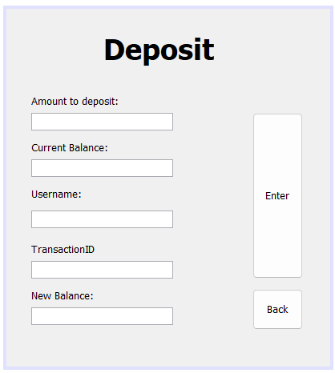

/*

* To change this license header, choose License Headers in Project Properties.

* To change this template file, choose Tools | Templates

* and open the template in the editor.

*/

package GenBank;

import java.sql.*;

import javax.swing.*;

/**

*

* @author ssuish

*/

public class Deposit extends javax.swing.JFrame {

/**

* Creates new form Deposit

*/

public Deposit() {

initComponents();

}

/**

* This method is called from within the constructor to initialize the form.

* WARNING: Do NOT modify this code. The content of this method is always

* regenerated by the Form Editor.

*/

@SuppressWarnings("unchecked")

// <editor-fold defaultstate="collapsed" desc="Generated Code">

private void initComponents() {

jLabel1 = new javax.swing.JLabel();

jLabel2 = new javax.swing.JLabel();

jTextField1 = new javax.swing.JTextField();

jLabel3 = new javax.swing.JLabel();

jTextField2 = new javax.swing.JTextField();

jLabel4 = new javax.swing.JLabel();

jTextField3 = new javax.swing.JTextField();

btnDeposit = new javax.swing.JButton();

btnBack = new javax.swing.JButton();

jLabel5 = new javax.swing.JLabel();

username = new javax.swing.JTextField();

jLabel6 = new javax.swing.JLabel();

transactionID = new javax.swing.JTextField();

setDefaultCloseOperation(javax.swing.WindowConstants.EXIT_ON_CLOSE);

jLabel1.setFont(new java.awt.Font("Tahoma", 1, 36)); // NOI18N

jLabel1.setText("Deposit");

jLabel2.setText("Amount to deposit:");

jLabel3.setText("Current Balance:");

jLabel4.setText("New Balance:");

btnDeposit.setText("Enter");

btnDeposit.addActionListener(new java.awt.event.ActionListener() {

public void actionPerformed(java.awt.event.ActionEvent evt) {

btnDepositActionPerformed(evt);

}

});

btnBack.setText("Back");

btnBack.addActionListener(new java.awt.event.ActionListener() {

public void actionPerformed(java.awt.event.ActionEvent evt) {

btnBackActionPerformed(evt);

}

});

jLabel5.setText("Username:");

jLabel6.setText("TransactionID");

javax.swing.GroupLayout layout = new javax.swing.GroupLayout(getContentPane());

getContentPane().setLayout(layout);

layout.setHorizontalGroup(

layout.createParallelGroup(javax.swing.GroupLayout.Alignment.LEADING)

.addGroup(layout.createSequentialGroup()

.addGap(31, 31, 31)

.addGroup(layout.createParallelGroup(javax.swing.GroupLayout.Alignment.LEADING)

.addComponent(username)

.addComponent(jTextField3, javax.swing.GroupLayout.DEFAULT_SIZE, 177, Short.MAX_VALUE)

.addComponent(jTextField1)

.addComponent(jTextField2)

.addComponent(transactionID)

.addGroup(layout.createSequentialGroup()

.addGroup(layout.createParallelGroup(javax.swing.GroupLayout.Alignment.LEADING)

.addComponent(jLabel3)

.addComponent(jLabel2)

.addComponent(jLabel4)

.addComponent(jLabel5)

.addComponent(jLabel6))

.addGap(0, 0, Short.MAX_VALUE)))

.addGap(99, 99, 99)

.addGroup(layout.createParallelGroup(javax.swing.GroupLayout.Alignment.LEADING, false)

.addComponent(btnDeposit, javax.swing.GroupLayout.DEFAULT_SIZE, javax.swing.GroupLayout.DEFAULT_SIZE, Short.MAX_VALUE)

.addComponent(btnBack, javax.swing.GroupLayout.DEFAULT_SIZE, javax.swing.GroupLayout.DEFAULT_SIZE, Short.MAX_VALUE))

.addGap(34, 34, 34))

.addGroup(layout.createSequentialGroup()

.addGap(121, 121, 121)

.addComponent(jLabel1)

.addContainerGap(javax.swing.GroupLayout.DEFAULT_SIZE, Short.MAX_VALUE))

);

layout.setVerticalGroup(

layout.createParallelGroup(javax.swing.GroupLayout.Alignment.LEADING)

.addGroup(layout.createSequentialGroup()

.addGap(28, 28, 28)

.addComponent(jLabel1)

.addGap(35, 35, 35)

.addComponent(jLabel2)

.addPreferredGap(javax.swing.LayoutStyle.ComponentPlacement.RELATED)

.addGroup(layout.createParallelGroup(javax.swing.GroupLayout.Alignment.LEADING)

.addGroup(layout.createSequentialGroup()

.addComponent(jTextField1, javax.swing.GroupLayout.PREFERRED_SIZE, javax.swing.GroupLayout.DEFAULT_SIZE, javax.swing.GroupLayout.PREFERRED_SIZE)

.addPreferredGap(javax.swing.LayoutStyle.ComponentPlacement.UNRELATED)

.addComponent(jLabel3)

.addPreferredGap(javax.swing.LayoutStyle.ComponentPlacement.RELATED)

.addComponent(jTextField2, javax.swing.GroupLayout.PREFERRED_SIZE, javax.swing.GroupLayout.DEFAULT_SIZE, javax.swing.GroupLayout.PREFERRED_SIZE)

.addPreferredGap(javax.swing.LayoutStyle.ComponentPlacement.UNRELATED)

.addComponent(jLabel5)

.addPreferredGap(javax.swing.LayoutStyle.ComponentPlacement.UNRELATED)

.addComponent(username, javax.swing.GroupLayout.PREFERRED_SIZE, javax.swing.GroupLayout.DEFAULT_SIZE, javax.swing.GroupLayout.PREFERRED_SIZE)

.addGap(18, 18, 18)

.addComponent(jLabel6)

.addPreferredGap(javax.swing.LayoutStyle.ComponentPlacement.RELATED, javax.swing.GroupLayout.DEFAULT_SIZE, Short.MAX_VALUE)

.addComponent(transactionID, javax.swing.GroupLayout.PREFERRED_SIZE, javax.swing.GroupLayout.DEFAULT_SIZE, javax.swing.GroupLayout.PREFERRED_SIZE))

.addComponent(btnDeposit, javax.swing.GroupLayout.DEFAULT_SIZE, javax.swing.GroupLayout.DEFAULT_SIZE, Short.MAX_VALUE))

.addPreferredGap(javax.swing.LayoutStyle.ComponentPlacement.UNRELATED)

.addGroup(layout.createParallelGroup(javax.swing.GroupLayout.Alignment.LEADING)

.addGroup(layout.createSequentialGroup()

.addComponent(jLabel4)

.addPreferredGap(javax.swing.LayoutStyle.ComponentPlacement.RELATED)

.addComponent(jTextField3, javax.swing.GroupLayout.PREFERRED_SIZE, javax.swing.GroupLayout.DEFAULT_SIZE, javax.swing.GroupLayout.PREFERRED_SIZE))

.addComponent(btnBack, javax.swing.GroupLayout.PREFERRED_SIZE, 51, javax.swing.GroupLayout.PREFERRED_SIZE))

.addGap(46, 46, 46))

);

pack();

}// </editor-fold>

private void btnBackActionPerformed(java.awt.event.ActionEvent evt) {

// TODO add your handling code here:

this.setVisible(false);

MainPage usrlogin = new MainPage();

usrlogin.setVisible(true);

}

private void btnDepositActionPerformed(java.awt.event.ActionEvent evt) {

// TODO add your handling code here:

String tcID = transactionID.getText();

String amtToDeposit = jTextField1.getText();

int newBal = 0;

int currBal = 0;

try {

Class.forName("org.apache.derby.jdbc.ClientDriver");

Connection con = DriverManager.getConnection("jdbc:derby://localhost:1527/BankingSystem", "admin123", "12345678");

// Retrieve the current balance

String getCurrBal = "SELECT balance FROM transactiontbl JOIN usertbl ON transactiontbl.transactionID = usertbl.transactionID WHERE username = '" + username.getText() + "'";

Statement stmt0 = con.createStatement();

ResultSet rs = stmt0.executeQuery(getCurrBal);

if (rs.next()) {

currBal = rs.getInt("balance");

}

// Calculate the new balance after deposit

newBal = currBal + Integer.parseInt(amtToDeposit);

// Display the current balance and new balance

jTextField2.setText(Integer.toString(currBal));

jTextField3.setText(Integer.toString(newBal));

// Perform the deposit by inserting a new record in the transaction table

Statement stmt = con.createStatement();

String query = "INSERT INTO transactiontbl (transactionID, balance, status, credit, debit, date) VALUES (" + Integer.parseInt(tcID) + ", " + newBal + ", 'Successful', 0, " + Integer.parseInt(amtToDeposit) + ", CURRENT_DATE)";

stmt.execute(query);

String query2 = "update transactiontbl set balance = balance + " + newBal + " where transactionID = " + Integer.parseInt(tcID);

stmt.execute(query2);

String query3 = "update usertbl set transactionID = " + Integer.parseInt(tcID) + " where username = '" + username.getText() + "'";

stmt.execute(query3);

con.close();

} catch (Exception e) {

e.printStackTrace();

JOptionPane.showMessageDialog(null, "Error occurred");

}

}

/**

* @param args the command line arguments

*/

public static void main(String args[]) {

/* Set the Nimbus look and feel */

//<editor-fold defaultstate="collapsed" desc=" Look and feel setting code (optional) ">

/* If Nimbus (introduced in Java SE 6) is not available, stay with the default look and feel.

* For details see http://download.oracle.com/javase/tutorial/uiswing/lookandfeel/plaf.html

*/

try {

for (javax.swing.UIManager.LookAndFeelInfo info : javax.swing.UIManager.getInstalledLookAndFeels()) {

if ("Nimbus".equals(info.getName())) {

javax.swing.UIManager.setLookAndFeel(info.getClassName());

break;

}

}

} catch (ClassNotFoundException ex) {

java.util.logging.Logger.getLogger(Deposit.class.getName()).log(java.util.logging.Level.SEVERE, null, ex);

} catch (InstantiationException ex) {

java.util.logging.Logger.getLogger(Deposit.class.getName()).log(java.util.logging.Level.SEVERE, null, ex);

} catch (IllegalAccessException ex) {

java.util.logging.Logger.getLogger(Deposit.class.getName()).log(java.util.logging.Level.SEVERE, null, ex);

} catch (javax.swing.UnsupportedLookAndFeelException ex) {

java.util.logging.Logger.getLogger(Deposit.class.getName()).log(java.util.logging.Level.SEVERE, null, ex);

}

//</editor-fold>

/* Create and display the form */

java.awt.EventQueue.invokeLater(new Runnable() {

public void run() {

new Deposit().setVisible(true);

}

});

}

// Variables declaration - do not modify

private javax.swing.JButton btnBack;

private javax.swing.JButton btnDeposit;

private javax.swing.JLabel jLabel1;

private javax.swing.JLabel jLabel2;

private javax.swing.JLabel jLabel3;

private javax.swing.JLabel jLabel4;

private javax.swing.JLabel jLabel5;

private javax.swing.JLabel jLabel6;

private javax.swing.JTextField jTextField1;

private javax.swing.JTextField jTextField2;

private javax.swing.JTextField jTextField3;

private javax.swing.JTextField transactionID;

private javax.swing.JTextField username;

// End of variables declaration

}

**PayBills.java**

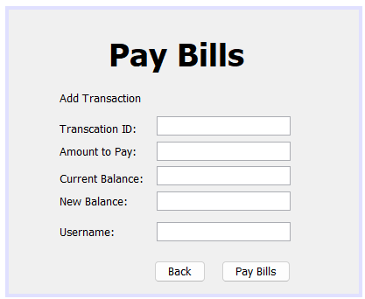

/*

* To change this license header, choose License Headers in Project Properties.

* To change this template file, choose Tools | Templates

* and open the template in the editor.

*/

package GenBank;

import java.sql.*;

import javax.swing.JOptionPane;

/**

*

* @author ssuish

*/

public class PayBills extends javax.swing.JFrame {

/**

* Creates new form PayBills

*/

public PayBills() {

initComponents();

}

/**

* This method is called from within the constructor to initialize the form.

* WARNING: Do NOT modify this code. The content of this method is always

* regenerated by the Form Editor.

*/

@SuppressWarnings("unchecked")

// <editor-fold defaultstate="collapsed" desc="Generated Code">

private void initComponents() {

jTextField3 = new javax.swing.JTextField();

jLabel2 = new javax.swing.JLabel();

jLabel1 = new javax.swing.JLabel();

jLabel3 = new javax.swing.JLabel();

jLabel4 = new javax.swing.JLabel();

jLabel5 = new javax.swing.JLabel();

txtTransactionID = new javax.swing.JTextField();

txtAmountToPay = new javax.swing.JTextField();

txtCurrentBalance = new javax.swing.JTextField();

txtNewBalance = new javax.swing.JTextField();

btnPayBills = new javax.swing.JButton();

btnBack = new javax.swing.JButton();

jLabel6 = new javax.swing.JLabel();

jLabel7 = new javax.swing.JLabel();

txtUsername = new javax.swing.JTextField();

jTextField3.setText("jTextField3");

setDefaultCloseOperation(javax.swing.WindowConstants.EXIT_ON_CLOSE);

jLabel2.setFont(new java.awt.Font("Tahoma", 1, 36)); // NOI18N

jLabel2.setText("Pay Bills");

jLabel1.setText("Transcation ID:");

jLabel3.setText("Amount to Pay:");

jLabel4.setText("Current Balance:");

jLabel5.setText("New Balance:");

btnPayBills.setText("Pay Bills");

btnPayBills.addActionListener(new java.awt.event.ActionListener() {

public void actionPerformed(java.awt.event.ActionEvent evt) {

btnPayBillsActionPerformed(evt);

}

});

btnBack.setText("Back");

btnBack.addActionListener(new java.awt.event.ActionListener() {

public void actionPerformed(java.awt.event.ActionEvent evt) {

btnBackActionPerformed(evt);

}

});

jLabel6.setText("Add Transaction");

jLabel7.setText("Username:");

javax.swing.GroupLayout layout = new javax.swing.GroupLayout(getContentPane());

getContentPane().setLayout(layout);

layout.setHorizontalGroup(

layout.createParallelGroup(javax.swing.GroupLayout.Alignment.LEADING)

.addGroup(javax.swing.GroupLayout.Alignment.TRAILING, layout.createSequentialGroup()

.addGroup(layout.createParallelGroup(javax.swing.GroupLayout.Alignment.TRAILING)

.addGroup(javax.swing.GroupLayout.Alignment.LEADING, layout.createSequentialGroup()

.addGap(114, 114, 114)

.addComponent(jLabel2)

.addGap(0, 53, Short.MAX_VALUE))

.addGroup(javax.swing.GroupLayout.Alignment.LEADING, layout.createSequentialGroup()

.addGap(58, 58, 58)

.addGroup(layout.createParallelGroup(javax.swing.GroupLayout.Alignment.LEADING)

.addGroup(layout.createSequentialGroup()

.addGroup(layout.createParallelGroup(javax.swing.GroupLayout.Alignment.LEADING)

.addComponent(jLabel3)

.addComponent(jLabel1)

.addComponent(jLabel6))

.addGap(18, 18, 18)

.addGroup(layout.createParallelGroup(javax.swing.GroupLayout.Alignment.LEADING)

.addComponent(txtTransactionID)

.addComponent(txtAmountToPay)))

.addGroup(layout.createSequentialGroup()

.addGroup(layout.createParallelGroup(javax.swing.GroupLayout.Alignment.LEADING)

.addComponent(jLabel4)

.addComponent(jLabel5)

.addComponent(jLabel7))

.addGap(15, 15, 15)

.addGroup(layout.createParallelGroup(javax.swing.GroupLayout.Alignment.LEADING)

.addComponent(txtCurrentBalance)

.addComponent(txtNewBalance)

.addComponent(txtUsername)))))

.addGroup(layout.createSequentialGroup()

.addContainerGap(javax.swing.GroupLayout.DEFAULT_SIZE, Short.MAX_VALUE)

.addComponent(btnBack)

.addGap(18, 18, 18)

.addComponent(btnPayBills)))

.addGap(78, 78, 78))

);

layout.setVerticalGroup(

layout.createParallelGroup(javax.swing.GroupLayout.Alignment.LEADING)

.addGroup(layout.createSequentialGroup()

.addGap(29, 29, 29)

.addComponent(jLabel2)

.addGap(20, 20, 20)

.addComponent(jLabel6)

.addPreferredGap(javax.swing.LayoutStyle.ComponentPlacement.UNRELATED)

.addGroup(layout.createParallelGroup(javax.swing.GroupLayout.Alignment.TRAILING)

.addComponent(jLabel1)

.addComponent(txtTransactionID, javax.swing.GroupLayout.PREFERRED_SIZE, javax.swing.GroupLayout.DEFAULT_SIZE, javax.swing.GroupLayout.PREFERRED_SIZE))

.addPreferredGap(javax.swing.LayoutStyle.ComponentPlacement.RELATED)

.addGroup(layout.createParallelGroup(javax.swing.GroupLayout.Alignment.BASELINE)

.addComponent(jLabel3)

.addComponent(txtAmountToPay, javax.swing.GroupLayout.PREFERRED_SIZE, javax.swing.GroupLayout.DEFAULT_SIZE, javax.swing.GroupLayout.PREFERRED_SIZE))

.addGroup(layout.createParallelGroup(javax.swing.GroupLayout.Alignment.LEADING)

.addGroup(layout.createSequentialGroup()

.addGap(12, 12, 12)

.addComponent(jLabel4))

.addGroup(javax.swing.GroupLayout.Alignment.TRAILING, layout.createSequentialGroup()

.addPreferredGap(javax.swing.LayoutStyle.ComponentPlacement.RELATED)

.addComponent(txtCurrentBalance, javax.swing.GroupLayout.PREFERRED_SIZE, javax.swing.GroupLayout.DEFAULT_SIZE, javax.swing.GroupLayout.PREFERRED_SIZE)))

.addPreferredGap(javax.swing.LayoutStyle.ComponentPlacement.RELATED)

.addGroup(layout.createParallelGroup(javax.swing.GroupLayout.Alignment.BASELINE)

.addComponent(txtNewBalance, javax.swing.GroupLayout.PREFERRED_SIZE, javax.swing.GroupLayout.DEFAULT_SIZE, javax.swing.GroupLayout.PREFERRED_SIZE)

.addComponent(jLabel5))

.addPreferredGap(javax.swing.LayoutStyle.ComponentPlacement.UNRELATED)

.addGroup(layout.createParallelGroup(javax.swing.GroupLayout.Alignment.BASELINE)

.addComponent(jLabel7)

.addComponent(txtUsername, javax.swing.GroupLayout.PREFERRED_SIZE, javax.swing.GroupLayout.DEFAULT_SIZE, javax.swing.GroupLayout.PREFERRED_SIZE))

.addPreferredGap(javax.swing.LayoutStyle.ComponentPlacement.RELATED, 22, Short.MAX_VALUE)

.addGroup(layout.createParallelGroup(javax.swing.GroupLayout.Alignment.BASELINE)

.addComponent(btnPayBills)

.addComponent(btnBack))

.addContainerGap())

);

pack();

}// </editor-fold>

private void jTextField2ActionPerformed(java.awt.event.ActionEvent evt) {

// TODO add your handling code here:

}

private void btnBackActionPerformed(java.awt.event.ActionEvent evt) {

// TODO add your handling code here:

this.setVisible(false);

MainPage usrlogin = new MainPage();

usrlogin.setVisible(true);

}

private void btnPayBillsActionPerformed(java.awt.event.ActionEvent evt) {

// TODO add your handling code here:

String tcID = txtTransactionID.getText();

String amtToPay = txtAmountToPay.getText();

int newBal = 0;

int currBal = 0;

// database connection for javadb and insert a new record based on string values

try {

Class.forName("org.apache.derby.jdbc.ClientDriver");

Connection con = DriverManager.getConnection("jdbc:derby://localhost:1527/BankingSystem", "admin123", "12345678");

Statement stmt0 = con.createStatement();

String getCurrBal = "select balance from transactiontbl join usertbl on transactiontbl.transactionID = usertbl.transactionID where username = '" + txtUsername.getText() + "'";

stmt0.execute(getCurrBal);

ResultSet rs = stmt0.getResultSet();

while (rs.next()) {

currBal = rs.getInt("balance");

}

newBal = currBal - Integer.parseInt(amtToPay);

txtCurrentBalance.setText(Integer.toString(currBal));

Statement stmt = con.createStatement();

// columns: transactionID(int), balance(numeric), status, debit(int), credit(int), date

String query = "insert into transactiontbl values (" + Integer.parseInt(tcID) + "," + newBal + ",'Succesful'," + Integer.parseInt(amtToPay) + ",0, CURRENT_DATE)";

stmt.execute(query);

txtNewBalance.setText(String.valueOf(newBal));

JOptionPane.showMessageDialog(null, "Payment Successful");

String query2 = "update transactiontbl set balance = balance - " + newBal + " where transactionID = " + Integer.parseInt(tcID);

stmt.execute(query2);

String query3 = "update usertbl set transactionID = " + Integer.parseInt(tcID) + " where username = '" + txtUsername.getText() + "'";

stmt.execute(query3);

con.close();

} catch (Exception e) {

System.out.println(e);

}

}

/**

* @param args the command line arguments

*/

public static void main(String args[]) {

/* Set the Nimbus look and feel */

//<editor-fold defaultstate="collapsed" desc=" Look and feel setting code (optional) ">

/* If Nimbus (introduced in Java SE 6) is not available, stay with the default look and feel.

* For details see http://download.oracle.com/javase/tutorial/uiswing/lookandfeel/plaf.html

*/

try {

for (javax.swing.UIManager.LookAndFeelInfo info : javax.swing.UIManager.getInstalledLookAndFeels()) {

if ("Nimbus".equals(info.getName())) {

javax.swing.UIManager.setLookAndFeel(info.getClassName());

break;

}

}

} catch (ClassNotFoundException ex) {

java.util.logging.Logger.getLogger(PayBills.class.getName()).log(java.util.logging.Level.SEVERE, null, ex);

} catch (InstantiationException ex) {

java.util.logging.Logger.getLogger(PayBills.class.getName()).log(java.util.logging.Level.SEVERE, null, ex);

} catch (IllegalAccessException ex) {

java.util.logging.Logger.getLogger(PayBills.class.getName()).log(java.util.logging.Level.SEVERE, null, ex);

} catch (javax.swing.UnsupportedLookAndFeelException ex) {

java.util.logging.Logger.getLogger(PayBills.class.getName()).log(java.util.logging.Level.SEVERE, null, ex);

}

//</editor-fold>

/* Create and display the form */

java.awt.EventQueue.invokeLater(new Runnable() {

public void run() {

new PayBills().setVisible(true);

}

});

}

// Variables declaration - do not modify

private javax.swing.JButton btnBack;

private javax.swing.JButton btnPayBills;

private javax.swing.JLabel jLabel1;

private javax.swing.JLabel jLabel2;

private javax.swing.JLabel jLabel3;

private javax.swing.JLabel jLabel4;

private javax.swing.JLabel jLabel5;

private javax.swing.JLabel jLabel6;

private javax.swing.JLabel jLabel7;

private javax.swing.JTextField jTextField3;

private javax.swing.JTextField txtAmountToPay;

private javax.swing.JTextField txtCurrentBalance;

private javax.swing.JTextField txtNewBalance;

private javax.swing.JTextField txtTransactionID;

private javax.swing.JTextField txtUsername;

// End of variables declaration

}

**UserResetPassword.java**

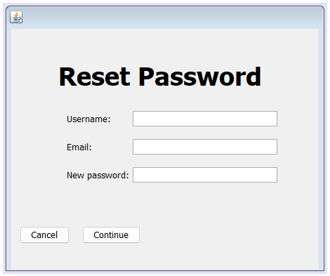

/*

* To change this license header, choose License Headers in Project Properties.

* To change this template file, choose Tools | Templates

* and open the template in the editor.

*/

package GenBank;

import java.sql.*;

import javax.swing.*;

import java.awt.*;

/**

*

* @author ssuish

*/

public class UserResetPassword extends javax.swing.JFrame {

/**

* Creates new form UserPasswordReset

*/

public UserResetPassword() {

initComponents();

}

/**

* This method is called from within the constructor to initialize the form.

* WARNING: Do NOT modify this code. The content of this method is always

* regenerated by the Form Editor.

*/

@SuppressWarnings("unchecked")

// <editor-fold defaultstate="collapsed" desc="Generated Code">

private void initComponents() {

jInternalFrame1 = new javax.swing.JInternalFrame();

jLabel1 = new javax.swing.JLabel();

jLabel2 = new javax.swing.JLabel();

jLabel3 = new javax.swing.JLabel();

jLabel4 = new javax.swing.JLabel();

btnBack = new javax.swing.JButton();

jButton2 = new javax.swing.JButton();

username = new javax.swing.JTextField();

email = new javax.swing.JTextField();

password = new javax.swing.JPasswordField();

setDefaultCloseOperation(javax.swing.WindowConstants.EXIT_ON_CLOSE);

jInternalFrame1.setVisible(true);

jLabel1.setFont(new java.awt.Font("Tahoma", 1, 36)); // NOI18N

jLabel1.setText("Reset Password");

jLabel2.setText("Username:");

jLabel3.setText("Email:");

jLabel4.setText("New password:");

btnBack.setText("Cancel");

btnBack.addActionListener(new java.awt.event.ActionListener() {

public void actionPerformed(java.awt.event.ActionEvent evt) {

btnBackActionPerformed(evt);

}

});

jButton2.setText("Continue");

jButton2.addActionListener(new java.awt.event.ActionListener() {

public void actionPerformed(java.awt.event.ActionEvent evt) {

jButton2ActionPerformed(evt);

}

});

javax.swing.GroupLayout jInternalFrame1Layout = new javax.swing.GroupLayout(jInternalFrame1.getContentPane());

jInternalFrame1.getContentPane().setLayout(jInternalFrame1Layout);

jInternalFrame1Layout.setHorizontalGroup(

jInternalFrame1Layout.createParallelGroup(javax.swing.GroupLayout.Alignment.LEADING)

.addGroup(javax.swing.GroupLayout.Alignment.TRAILING, jInternalFrame1Layout.createSequentialGroup()

.addContainerGap(67, Short.MAX_VALUE)

.addComponent(jLabel1)

.addGap(81, 81, 81))

.addGroup(jInternalFrame1Layout.createSequentialGroup()

.addGroup(jInternalFrame1Layout.createParallelGroup(javax.swing.GroupLayout.Alignment.LEADING)

.addGroup(jInternalFrame1Layout.createSequentialGroup()

.addContainerGap()

.addComponent(btnBack)

.addGap(18, 18, 18)

.addComponent(jButton2))

.addGroup(jInternalFrame1Layout.createSequentialGroup()

.addGap(79, 79, 79)

.addGroup(jInternalFrame1Layout.createParallelGroup(javax.swing.GroupLayout.Alignment.LEADING)

.addGroup(jInternalFrame1Layout.createSequentialGroup()

.addComponent(jLabel4)

.addPreferredGap(javax.swing.LayoutStyle.ComponentPlacement.RELATED)

.addComponent(password))

.addGroup(jInternalFrame1Layout.createSequentialGroup()

.addGroup(jInternalFrame1Layout.createParallelGroup(javax.swing.GroupLayout.Alignment.LEADING)

.addComponent(jLabel2)

.addComponent(jLabel3))

.addGap(31, 31, 31)

.addGroup(jInternalFrame1Layout.createParallelGroup(javax.swing.GroupLayout.Alignment.LEADING)

.addComponent(username)

.addComponent(email))))))

.addGap(59, 59, 59))

);

jInternalFrame1Layout.setVerticalGroup(

jInternalFrame1Layout.createParallelGroup(javax.swing.GroupLayout.Alignment.LEADING)

.addGroup(jInternalFrame1Layout.createSequentialGroup()

.addGap(45, 45, 45)

.addComponent(jLabel1)

.addGap(28, 28, 28)

.addGroup(jInternalFrame1Layout.createParallelGroup(javax.swing.GroupLayout.Alignment.BASELINE)

.addComponent(jLabel2)

.addComponent(username, javax.swing.GroupLayout.PREFERRED_SIZE, javax.swing.GroupLayout.DEFAULT_SIZE, javax.swing.GroupLayout.PREFERRED_SIZE))

.addGap(18, 18, 18)

.addGroup(jInternalFrame1Layout.createParallelGroup(javax.swing.GroupLayout.Alignment.BASELINE)

.addComponent(jLabel3)

.addComponent(email, javax.swing.GroupLayout.PREFERRED_SIZE, javax.swing.GroupLayout.DEFAULT_SIZE, javax.swing.GroupLayout.PREFERRED_SIZE))

.addGap(18, 18, 18)

.addGroup(jInternalFrame1Layout.createParallelGroup(javax.swing.GroupLayout.Alignment.BASELINE)

.addComponent(jLabel4)

.addComponent(password, javax.swing.GroupLayout.PREFERRED_SIZE, javax.swing.GroupLayout.DEFAULT_SIZE, javax.swing.GroupLayout.PREFERRED_SIZE))

.addPreferredGap(javax.swing.LayoutStyle.ComponentPlacement.RELATED, 58, Short.MAX_VALUE)

.addGroup(jInternalFrame1Layout.createParallelGroup(javax.swing.GroupLayout.Alignment.BASELINE)

.addComponent(btnBack)

.addComponent(jButton2))

.addGap(36, 36, 36))

);

javax.swing.GroupLayout layout = new javax.swing.GroupLayout(getContentPane());

getContentPane().setLayout(layout);

layout.setHorizontalGroup(

layout.createParallelGroup(javax.swing.GroupLayout.Alignment.LEADING)

.addComponent(jInternalFrame1)

);

layout.setVerticalGroup(

layout.createParallelGroup(javax.swing.GroupLayout.Alignment.LEADING)

.addComponent(jInternalFrame1)

);

pack();

}// </editor-fold>

private void jButton2ActionPerformed(java.awt.event.ActionEvent evt) {

// TODO add your handling code here:

String sql = "SELECT * FROM USERTBL";

String sql2 = "UPDATE USERTBL SET password = ? WHERE username = ?";

try {

Class.forName("org.apache.derby.jdbc.ClientDriver");

Connection con = DriverManager.getConnection("jdbc:derby://localhost:1527/BankingSystem", "admin123", "12345678");

Statement stmt = con.createStatement();

ResultSet rs = stmt.executeQuery(sql);

String user = username.getText();

String em = email.getText();

String pwd = new String(password.getPassword());

while (rs.next()) {

String uname = rs.getString("username");

String email = rs.getString("email");

String password = rs.getString("password");

if (user.equals(uname) && em.equals(email)) {

PreparedStatement pstmt = con.prepareStatement(sql2);

pstmt.setString(1, pwd);

pstmt.setString(2, user);

pstmt.executeUpdate();

JOptionPane.showMessageDialog(null, "Password Changed");

new UserLogin().setVisible(true);

break;

}

else{

JOptionPane.showMessageDialog(null, "Username and Email Incorrect");

UserLogin UL = new UserLogin();

UL.setVisible(true);

this.dispose();

break;

}

}

con.close();

this.dispose();

} catch (Exception e) {

JOptionPane.showMessageDialog(null, e.getMessage());

}

}

private void btnBackActionPerformed(java.awt.event.ActionEvent evt) {

// TODO add your handling code here:

this.setVisible(false);

UserLogin usrlogin = new UserLogin();

usrlogin.setVisible(true);

}

/**

* @param args the command line arguments

*/

public static void main(String args[]) {

/* Set the Nimbus look and feel */

//<editor-fold defaultstate="collapsed" desc=" Look and feel setting code (optional) ">

/* If Nimbus (introduced in Java SE 6) is not available, stay with the default look and feel.

* For details see http://download.oracle.com/javase/tutorial/uiswing/lookandfeel/plaf.html

*/

try {

for (javax.swing.UIManager.LookAndFeelInfo info : javax.swing.UIManager.getInstalledLookAndFeels()) {

if ("Nimbus".equals(info.getName())) {

javax.swing.UIManager.setLookAndFeel(info.getClassName());

break;

}

}

} catch (ClassNotFoundException ex) {

java.util.logging.Logger.getLogger(UserResetPassword.class.getName()).log(java.util.logging.Level.SEVERE, null, ex);

} catch (InstantiationException ex) {

java.util.logging.Logger.getLogger(UserResetPassword.class.getName()).log(java.util.logging.Level.SEVERE, null, ex);

} catch (IllegalAccessException ex) {

java.util.logging.Logger.getLogger(UserResetPassword.class.getName()).log(java.util.logging.Level.SEVERE, null, ex);

} catch (javax.swing.UnsupportedLookAndFeelException ex) {

java.util.logging.Logger.getLogger(UserResetPassword.class.getName()).log(java.util.logging.Level.SEVERE, null, ex);

}

//</editor-fold>

//</editor-fold>

//</editor-fold>

//</editor-fold>

/* Create and display the form */

java.awt.EventQueue.invokeLater(new Runnable() {

public void run() {

new UserResetPassword().setVisible(true);

}

});

}

// Variables declaration - do not modify

private javax.swing.JButton btnBack;

private javax.swing.JTextField email;

private javax.swing.JButton jButton2;

private javax.swing.JInternalFrame jInternalFrame1;

private javax.swing.JLabel jLabel1;

private javax.swing.JLabel jLabel2;

private javax.swing.JLabel jLabel3;

private javax.swing.JLabel jLabel4;

private javax.swing.JPasswordField password;

private javax.swing.JTextField username;

// End of variables declaration

}

**UserCreateAccount.java**

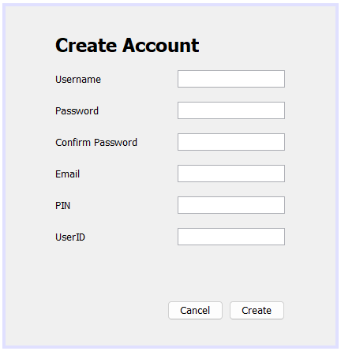

/*

* To change this license header, choose License Headers in Project Properties.

* To change this template file, choose Tools | Templates

* and open the template in the editor.

*/

package GenBank;

import java.sql.*;

import javax.swing.JOptionPane;

/**

*

* @author ssuish

*/

public class UserCreateAccount extends javax.swing.JFrame {

/**

* Creates new form UserCreateAccount

*/

public UserCreateAccount() {

initComponents();

}

/**

* This method is called from within the constructor to initialize the form.

* WARNING: Do NOT modify this code. The content of this method is always

* regenerated by the Form Editor.

*/

@SuppressWarnings("unchecked")

// <editor-fold defaultstate="collapsed" desc="Generated Code">

private void initComponents() {

jLabel7 = new javax.swing.JLabel();

jLabel1 = new javax.swing.JLabel();

jLabel2 = new javax.swing.JLabel();

jLabel3 = new javax.swing.JLabel();

jLabel4 = new javax.swing.JLabel();

jLabel5 = new javax.swing.JLabel();

jLabel6 = new javax.swing.JLabel();

username = new javax.swing.JTextField();

btnBack = new javax.swing.JButton();

btnCreate = new javax.swing.JButton();

email = new javax.swing.JTextField();

pin = new javax.swing.JTextField();

jLabel8 = new javax.swing.JLabel();

userID = new javax.swing.JTextField();

password = new javax.swing.JPasswordField();

cpassword = new javax.swing.JPasswordField();

jLabel9 = new javax.swing.JLabel();

jLabel7.setText("jLabel7");

setDefaultCloseOperation(javax.swing.WindowConstants.EXIT_ON_CLOSE);

jLabel1.setFont(new java.awt.Font("Tahoma", 1, 24)); // NOI18N

jLabel1.setText("Create Account");

jLabel2.setText("Username");

jLabel3.setText("Password");

jLabel4.setText("Confirm Password");

jLabel5.setText("PIN");

jLabel6.setText("Email");

btnBack.setText("Cancel");

btnBack.addActionListener(new java.awt.event.ActionListener() {

public void actionPerformed(java.awt.event.ActionEvent evt) {

btnBackActionPerformed(evt);

}

});

btnCreate.setText("Create");

btnCreate.addActionListener(new java.awt.event.ActionListener() {

public void actionPerformed(java.awt.event.ActionEvent evt) {

btnCreateActionPerformed(evt);

}

});

jLabel8.setText("UserID");

javax.swing.GroupLayout layout = new javax.swing.GroupLayout(getContentPane());

getContentPane().setLayout(layout);

layout.setHorizontalGroup(

layout.createParallelGroup(javax.swing.GroupLayout.Alignment.LEADING)

.addGroup(layout.createSequentialGroup()

.addGap(63, 63, 63)

.addGroup(layout.createParallelGroup(javax.swing.GroupLayout.Alignment.LEADING)

.addComponent(jLabel1)

.addGroup(layout.createParallelGroup(javax.swing.GroupLayout.Alignment.TRAILING)

.addGroup(layout.createSequentialGroup()

.addComponent(btnBack)

.addPreferredGap(javax.swing.LayoutStyle.ComponentPlacement.RELATED)

.addComponent(btnCreate))

.addGroup(layout.createSequentialGroup()

.addGroup(layout.createParallelGroup(javax.swing.GroupLayout.Alignment.LEADING)

.addComponent(jLabel2)

.addComponent(jLabel3)

.addComponent(jLabel4)

.addComponent(jLabel6)

.addComponent(jLabel5)

.addComponent(jLabel8)

.addComponent(jLabel9))

.addGap(51, 51, 51)

.addGroup(layout.createParallelGroup(javax.swing.GroupLayout.Alignment.LEADING, false)

.addComponent(username, javax.swing.GroupLayout.DEFAULT_SIZE, 136, Short.MAX_VALUE)

.addComponent(email)

.addComponent(pin)

.addComponent(userID)

.addComponent(password)

.addComponent(cpassword)))))

.addContainerGap(64, Short.MAX_VALUE))

);

layout.setVerticalGroup(

layout.createParallelGroup(javax.swing.GroupLayout.Alignment.LEADING)

.addGroup(layout.createSequentialGroup()

.addGap(34, 34, 34)

.addComponent(jLabel1)

.addGap(18, 18, 18)

.addGroup(layout.createParallelGroup(javax.swing.GroupLayout.Alignment.BASELINE)

.addComponent(jLabel2)

.addComponent(username, javax.swing.GroupLayout.PREFERRED_SIZE, javax.swing.GroupLayout.DEFAULT_SIZE, javax.swing.GroupLayout.PREFERRED_SIZE))

.addGap(18, 18, 18)

.addGroup(layout.createParallelGroup(javax.swing.GroupLayout.Alignment.BASELINE)

.addComponent(jLabel3)

.addComponent(password, javax.swing.GroupLayout.PREFERRED_SIZE, javax.swing.GroupLayout.DEFAULT_SIZE, javax.swing.GroupLayout.PREFERRED_SIZE))

.addGap(18, 18, 18)

.addGroup(layout.createParallelGroup(javax.swing.GroupLayout.Alignment.BASELINE)

.addComponent(jLabel4)

.addComponent(cpassword, javax.swing.GroupLayout.PREFERRED_SIZE, javax.swing.GroupLayout.DEFAULT_SIZE, javax.swing.GroupLayout.PREFERRED_SIZE))

.addGap(18, 18, 18)

.addGroup(layout.createParallelGroup(javax.swing.GroupLayout.Alignment.BASELINE)

.addComponent(jLabel6)

.addComponent(email, javax.swing.GroupLayout.PREFERRED_SIZE, javax.swing.GroupLayout.DEFAULT_SIZE, javax.swing.GroupLayout.PREFERRED_SIZE))

.addGap(18, 18, 18)

.addGroup(layout.createParallelGroup(javax.swing.GroupLayout.Alignment.BASELINE)

.addComponent(jLabel5)

.addComponent(pin, javax.swing.GroupLayout.PREFERRED_SIZE, javax.swing.GroupLayout.DEFAULT_SIZE, javax.swing.GroupLayout.PREFERRED_SIZE))

.addGap(18, 18, 18)

.addGroup(layout.createParallelGroup(javax.swing.GroupLayout.Alignment.BASELINE)

.addComponent(jLabel8)

.addComponent(userID, javax.swing.GroupLayout.PREFERRED_SIZE, javax.swing.GroupLayout.DEFAULT_SIZE, javax.swing.GroupLayout.PREFERRED_SIZE))

.addGap(18, 18, 18)

.addComponent(jLabel9)

.addPreferredGap(javax.swing.LayoutStyle.ComponentPlacement.RELATED, 52, Short.MAX_VALUE)

.addGroup(layout.createParallelGroup(javax.swing.GroupLayout.Alignment.BASELINE)

.addComponent(btnCreate)

.addComponent(btnBack))

.addGap(32, 32, 32))

);

pack();

}// </editor-fold>

private void btnBackActionPerformed(java.awt.event.ActionEvent evt) {

// TODO add your handling code here:

this.setVisible(false);

UserLogin usrlogin = new UserLogin();

usrlogin.setVisible(true);

}

private void btnCreateActionPerformed(java.awt.event.ActionEvent evt) {

// TODO add your handling code here:

// database connection javadb

try {

Class.forName("org.apache.derby.jdbc.ClientDriver");

Connection con = DriverManager.getConnection("jdbc:derby://localhost:1527/BankingSystem", "user123", "12345678");

PreparedStatement ps = con.prepareStatement("insert into USERDETAILS values(?,?,?,?,?,?)");

ps.setString(1, userID.getText());

String pd = new String(password.getPassword());

String cpd = new String(password.getPassword());

ps.setString(2, username.getText());

ps.setString(3, pd);

ps.setString(4, email.getText());

ps.setString(5, pin.getText());

ps.setString(6, "null");

int i = ps.executeUpdate();

if (i > 0) {

JOptionPane.showMessageDialog(null, "Account Created Successfully");

this.setVisible(false);

UserLogin usrlogin = new UserLogin();

usrlogin.setVisible(true);

} else {

JOptionPane.showMessageDialog(null, "Account Not Created");

}

this.setVisible(false);

new UserLogin().setVisible(true);

} catch (Exception ex) {

System.out.println(ex);

}

}

/**

* @param args the command line arguments

*/

public static void main(String args[]) {

/* Set the Nimbus look and feel */

//<editor-fold defaultstate="collapsed" desc=" Look and feel setting code (optional) ">

/* If Nimbus (introduced in Java SE 6) is not available, stay with the default look and feel.

* For details see http://download.oracle.com/javase/tutorial/uiswing/lookandfeel/plaf.html

*/

try {

for (javax.swing.UIManager.LookAndFeelInfo info : javax.swing.UIManager.getInstalledLookAndFeels()) {

if ("Nimbus".equals(info.getName())) {

javax.swing.UIManager.setLookAndFeel(info.getClassName());

break;

}

}

} catch (ClassNotFoundException ex) {

java.util.logging.Logger.getLogger(UserCreateAccount.class.getName()).log(java.util.logging.Level.SEVERE, null, ex);

} catch (InstantiationException ex) {

java.util.logging.Logger.getLogger(UserCreateAccount.class.getName()).log(java.util.logging.Level.SEVERE, null, ex);

} catch (IllegalAccessException ex) {

java.util.logging.Logger.getLogger(UserCreateAccount.class.getName()).log(java.util.logging.Level.SEVERE, null, ex);

} catch (javax.swing.UnsupportedLookAndFeelException ex) {

java.util.logging.Logger.getLogger(UserCreateAccount.class.getName()).log(java.util.logging.Level.SEVERE, null, ex);

}

//</editor-fold>

/* Create and display the form */

java.awt.EventQueue.invokeLater(new Runnable() {

public void run() {

new UserCreateAccount().setVisible(true);

}

});

}

// Variables declaration - do not modify

private javax.swing.JButton btnBack;

private javax.swing.JButton btnCreate;

private javax.swing.JPasswordField cpassword;

private javax.swing.JTextField email;

private javax.swing.JLabel jLabel1;

private javax.swing.JLabel jLabel2;

private javax.swing.JLabel jLabel3;

private javax.swing.JLabel jLabel4;

private javax.swing.JLabel jLabel5;

private javax.swing.JLabel jLabel6;

private javax.swing.JLabel jLabel7;

private javax.swing.JLabel jLabel8;

private javax.swing.JLabel jLabel9;

private javax.swing.JPasswordField password;

private javax.swing.JTextField pin;

private javax.swing.JTextField userID;

private javax.swing.JTextField username;

// End of variables declaration

}

1. Screenshots of the Output (minimum of 5 images)

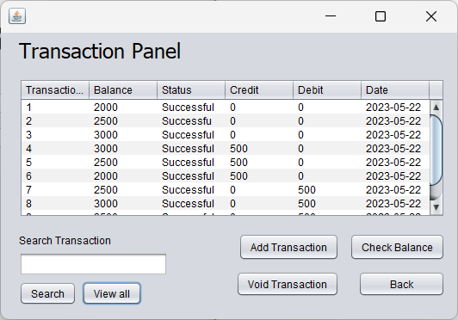

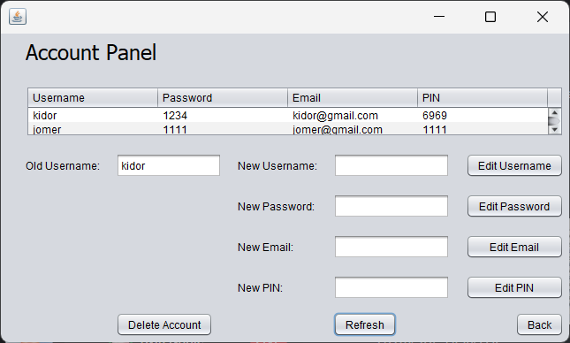

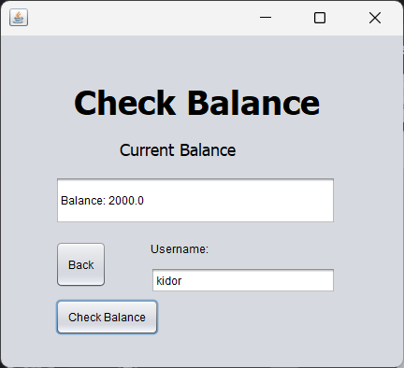

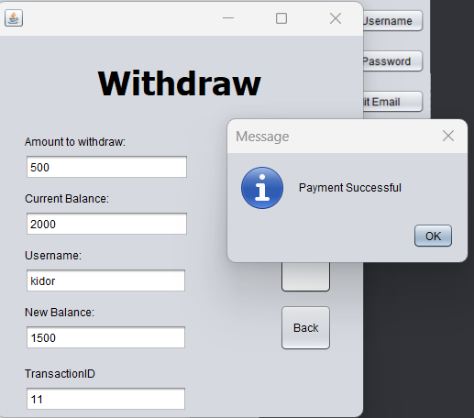

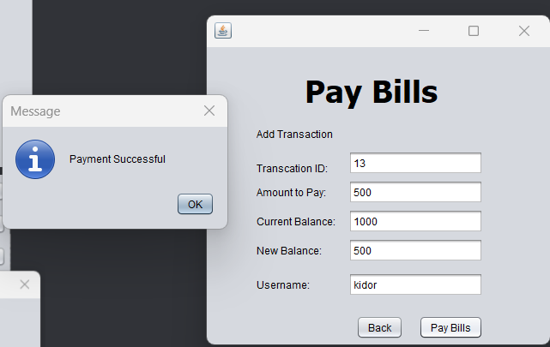

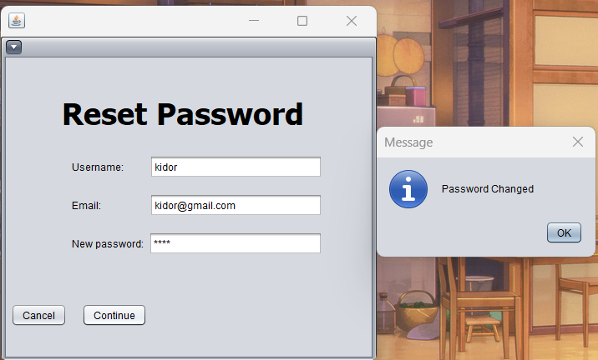

1. Evidence of individual participation/group collaboration – (minimum of 5 images)

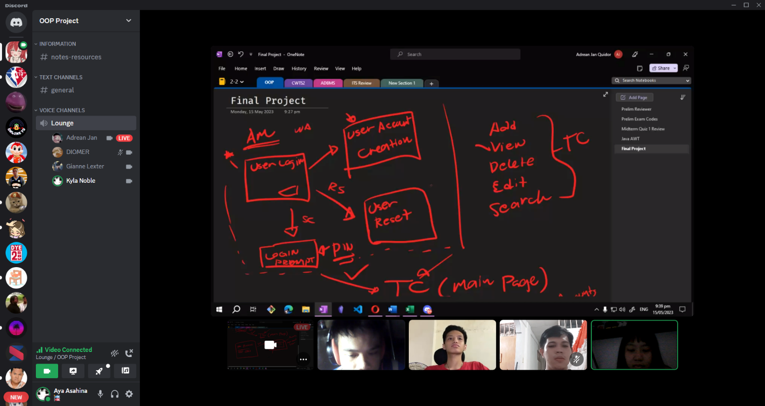

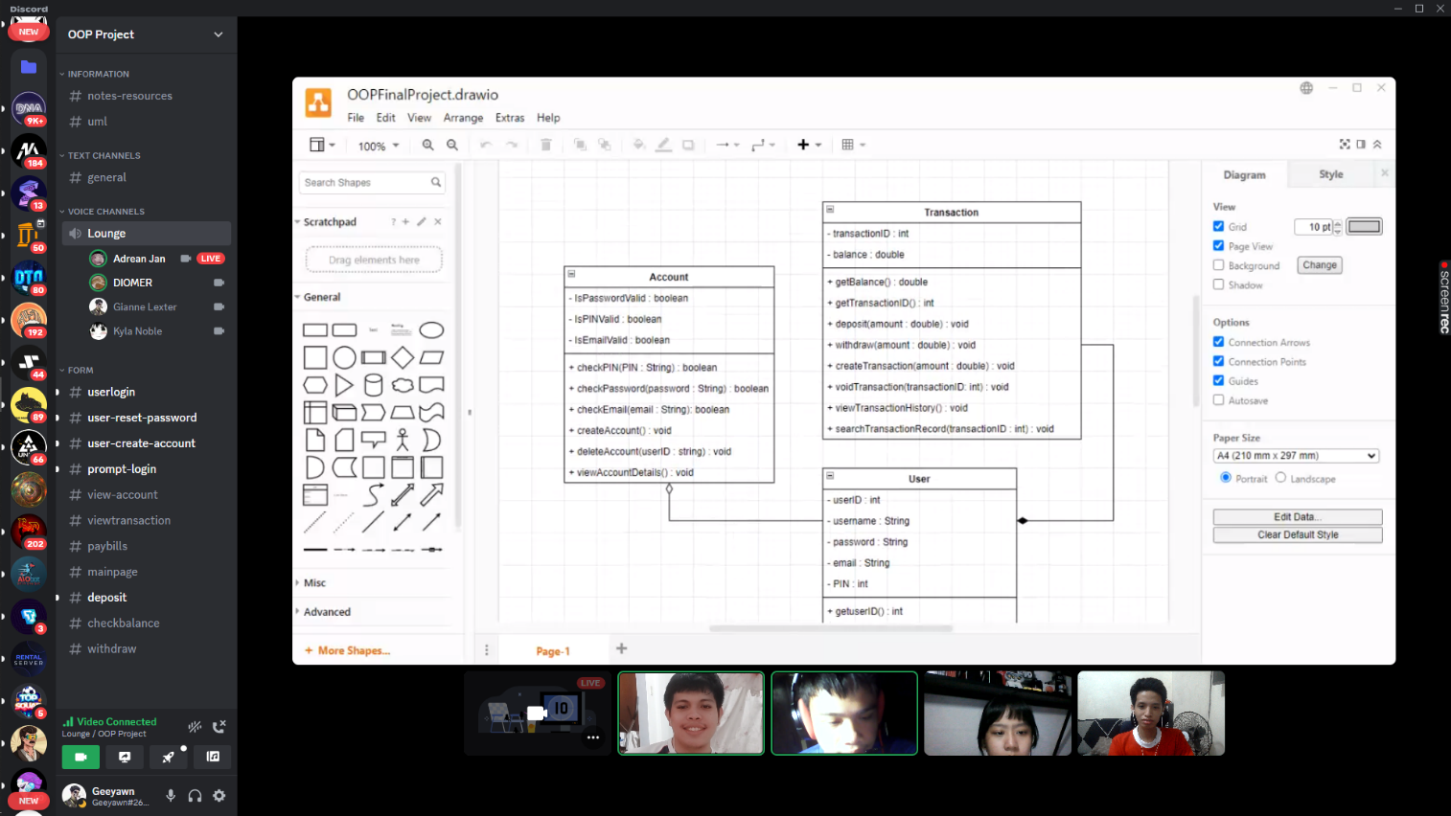

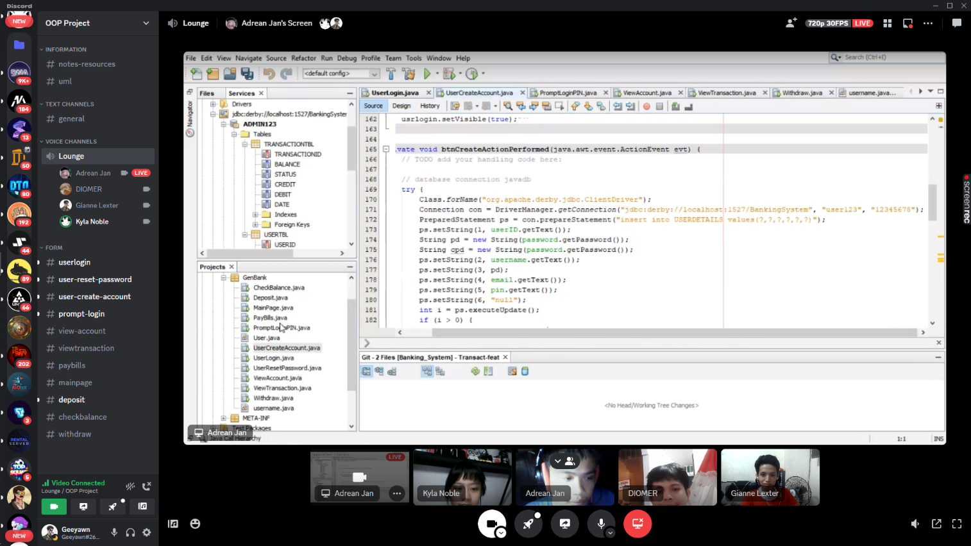

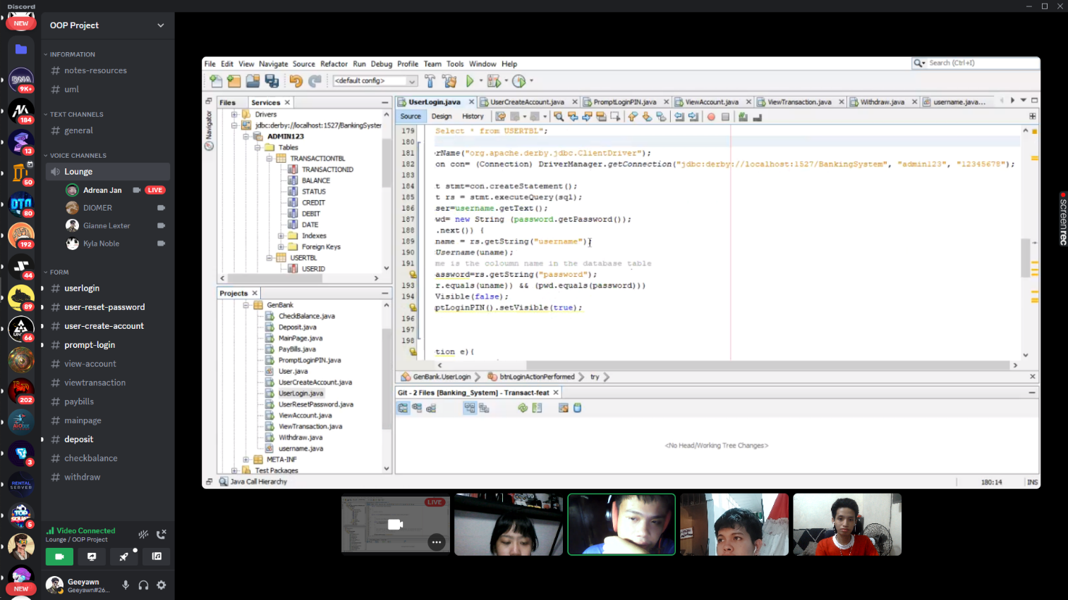

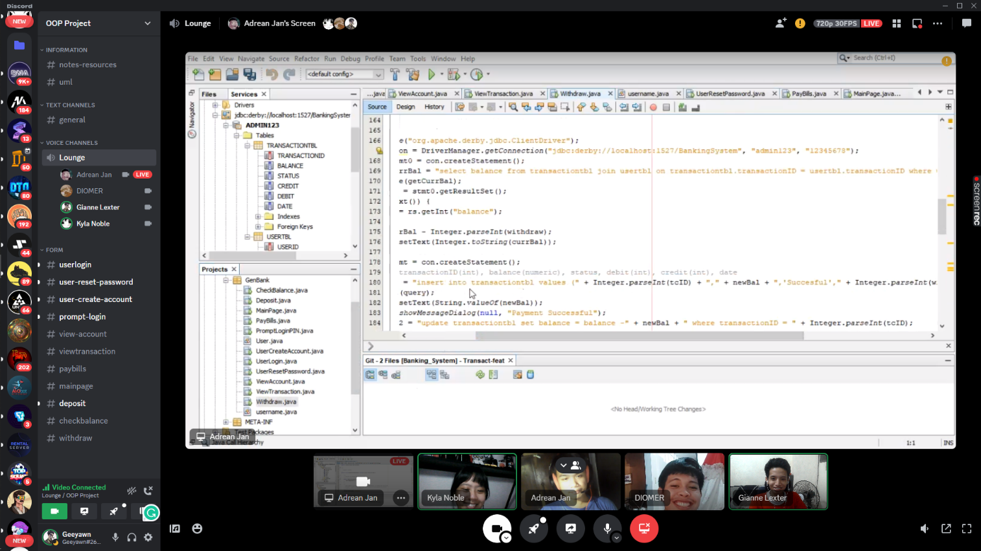

1. Evaluation – Answer the following questions:
2. What are the OOP Principles have you applied in the system? Explain briefly.

Object-oriented programming (OOP) concepts consist of abstraction, encapsulation, inheritance, and polymorphism. These principles play a crucial role in developing organized and reusable objects in programming. They serve as the building blocks for OOP in various programming languages and facilitate the creation of well-structured and maintainable code. In our project, we specifically utilized encapsulation and inheritance as key principles. These principles were chosen for specific reasons.

Encapsulation involves bundling data and methods together within a class, allowing for controlled access and manipulation of the object's internal state. Encapsulating data ensures that it is only accessed and modified through designated methods, providing data integrity and security. For example, the details of a customer's account number and balance can be encapsulated within an account object. This prevents users from accessing this data directly and can only be accessed through the account object's methods. It can also help improve data integrity by preventing users from modifying data they should not be able to. The interest rate on a bank account can be encapsulated within an account object. This prevents users from modifying the interest rate directly and can only be modified through the account object's methods. Lastly, it will reduce the complexity of a banking system by hiding the implementation details of objects from users. This makes it easier for users to understand and use the system.

Inheritance provides the ability to establish a class hierarchy, enabling child classes to inherit attributes and behaviors from parent classes. This facilitates code reuse, as shared characteristics can be defined in a parent class and inherited by multiple child classes. It promotes code organization and structure, reducing redundancy and enhancing maintainability. By leveraging inheritance, we were able to create new classes that inherit from existing ones, such as different account types inheriting from a common base class representing an account. This approach saves time and effort for developers as they don't need to write code from scratch, while also improving code readability by showcasing the relationships between different classes. These principles simplify debugging and maintenance processes and reduce the complexity of a banking system by enabling the creation of a structured class hierarchy.

1. What is the importance of having a UML Class Diagram before creating a system?

The application of the Unified Modeling Language (UML) in the design phase of our banking system proved highly beneficial. UML, being a graphical representation language, enabled us to effectively communicate and understand the structure, behavior, and interactions within the software system. The utilization of UML diagrams facilitated conveying system designs to stakeholders, fostering a shared understanding among customers, developers, and managers. By employing UML, we were able to create class diagrams, sequence diagrams, and activity diagrams, which provided visual representations of the system's structure, class relationships, operational flow, and overall behavior. These diagrams played a pivotal role in making well-informed design decisions and effectively organizing the system's components. Consequently, UML significantly supported the development, testing, and maintenance processes, allowing for a comprehensive understanding of the system's structure and behavior.

1. How would you recommend your created transaction processing system in a certain company or organization?

To recommend the banking system to new and small organizations entering the market, our approach will focus on their specific needs and the potential benefits they can derive from the system. We will target individuals who already have experience with similar systems, as their insights and advice would be valuable to our group. Our evaluation process will thoroughly assess the features, functionalities, and capabilities of the banking system to ensure they align with the unique requirements of the company. We will pay particular attention to how effectively the system addresses the pain points commonly experienced by new organizations, such as streamlining processes, enhancing efficiency, and supporting growth. Furthermore, we will emphasize the importance of pilot testing and feedback. By conducting small-scale trials, we can gather input from users to identify any issues or areas that require improvement. This approach allows us to incorporate necessary customization and refinements before implementing the system on a larger scale.